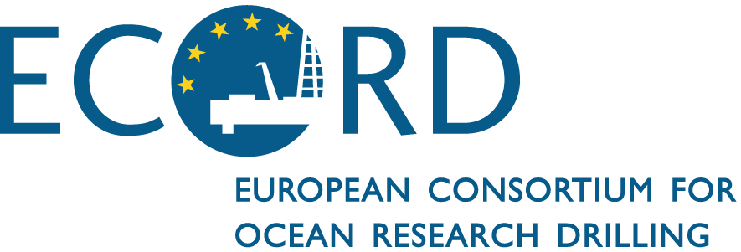

ECORD Facility Board Meeting #4
15th and 16th of June 2016
Royal Academy of Sciences
Brussels, Belgium

EXECUTIVE SUMMARY

1. Introduction
G. Lericolais opened the meeting and presented the rules of engagement. J.-P. Henriet presented the logistical information and the meeting participants started with the self-introduction.

ECORD FB Consensus 16-06-01:
The ECORD Facility Board approves the agenda of the ECORD FB Meeting #4.

2. Brief reports of ECORD Facility Board (EFB) and other ECORD entities
Reports were presented for the EFB (G. Lericolais), EMA (N. Hallmann), ESO (D. McInroy), the BCR (U. Röhl), the EPC (S. Davies), ESO outreach/education (A. Stevenson), ESSAC (J. Behrmann).

3. Brief reports of other IODP facility boards and entities on recent activities
There were reports on the JR-FB (A. Koppers), the CIB (N. Eguchi), the Science Support Office (H. Given), the Science Evaluation Panel (K. Miller) and the IODP Forum (J. Austin).

- ACTION (EFB): The ECORD Facility Board revises the sentence “MSP expeditions are planned to operate once per year on average, and proposals for any ocean are welcomed.” in the call for proposals for Scientific Ocean Drilling until early July 2016.

4. Review of the MSP proposals
Six MSP proposals that are currently at the ECORD FB were reviewed and discussed: 1) #581 Late Pleistocene Coralgal Banks; 2) #637 New England Shelf Hydrogeology; 3) #716 Hawaiian Drowned Reefs; 4) #708 Central Arctic Paleoceanography; 5) #730 Sabine Bank Sea Level and 6) #879 Corinth Active Rift Development.

- ACTION (EFB): The ECORD Facility Board contacts the proponents of proposal #708 ‘Central Arctic Paleoceanography’ (1) to emphasize the restriction of total string length (2 km) due to budget and operational constraints, and (2) to stress that two sites most likely can accomplish primary objectives. These objectives are to reach through the orange reflector, and to obtain a high-resolution record of the Plio-Pleistocene. The proponents are asked to prioritize the sites they consider best, as well as offer possible sites that are presently within 1 km of currently proposed primary and alternate sites. This information should be directly forwarded to the EFB before July 1, 2016.

- ACTION (EFB): The ECORD Facility Board asks SEP to comment on alternate sites of Proposal #708 that already have been submitted to SEP that can achieve primary scientific objectives within the 2 km total string length restriction. This assessment should be made before the next EPSP meeting (11-13 July, 2016).

ECORD FB Consensus 16-06-02:
The ECORD Facility Board decides to deactivate proposal #581 ‘Late Pleistocene Coralgal Banks’.

- ACTION (EFB): The ECORD Facility Board contacts the proponents of proposal #637 ‘New England Shelf Hydrogeology’ to inform them that despite the strength of the proposal, other very strong and costly proposals were considered. Thus, ECORD is not able to drill the present proposal within the next five years at currently projected funding levels.
The EFB encouraged the proponents to consider options for de-scoping the proposal at a workshop. Nonetheless, we kept this proposal in the “EFB waiting room” in the hope that greater funding might occur in the second phase of the IODP-ECORD program.
ECORD FB Consensus 16-06-03:
The ECORD Facility Board ranks proposal #716 ‘Hawaiian Drowned Reefs’ as the highest-priority proposal within the “sea-level theme” and proposal #730 ‘Sabine Bank Sea Level’ a secondary priority.

ECORD FB Consensus 16-06-04:
The ECORD Facility Board considers proposal #879 ‘Corinth Active Rift Development’ as a high-priority proposal.

5. Preview of the MSP operation schedule for FY 2019 - 2023
MSP proposals that are currently at the ECORD FB were discussed during a breakout meeting of the EFB Science Board members. Afterwards the recommendations of the EFB Science Board members were presented to and discussed with all meeting attendees.

ECORD FB Consensus 16-06-05:
The ECORD Facility Board acknowledges a substantial annual short fall (i.e. $5-10M) in ECORD funding to accomplish available and anticipated high quality, high impact science proposals that use high cost MSP drilling platforms. This is especially true, considering the renewal of the IODP Memoranda of Understandings (MoUs).

ECORD FB Consensus 16-06-06:
The ECORD Facility Board recommends that the proponents planning to use sea-bed drilling and long-piston coring apply for ship time early in the process within their national agencies to facilitate MSP proposal realization.

- ACTION (ESO): The ECORD Facility Board recommends that ESO contacts international research fleet operators to evaluate possible costs of national research vessels to carry sea-bed drills or use of long-piston cores.

6. Procedures and issues regarding EFB activities and MSP operations
W. Roest presented the United Nations Convention on the Law of the Sea and a potential impact on ECORD’s activities was discussed. D. McInroy reported on the implementation plan for the Amphibious Drilling Proposals.

- ACTION (EFB): The ECORD Facility Board members will review documents on policies and guidelines and respond to IODP-SSO.

9. Next EFB meeting

- ACTION (N. Hallmann): to get in contact with potential hosts of the next ECORD Facility Board meeting.

This ECORD Facility Board meeting was organized in cooperation with the Royal Flemish Academy of Science and Arts of Belgium (KVAB).

