

**ECORD Council Spring Meeting #1**

**Swedish Research Council, Stockholm, Sweden**

**MINUTES**

***March 12th, 2015***

**TABLE OF CONTENTS**

1 – Self introduction and logistical information (M. Diament/M. Friberg) 1

2 – Approval of the agenda (G. Camoin) 1

3 – ECORD news and budget (G. Camoin) 2

4 – ESO: Scoping/tender process, operations, technical developments (D. McInroy) 5

5 – Mid to long-term MSP scheduling (K. Gohl) 10

6 – Overview of active MSP proposals (K. Gohl) 10

7 – MSP proposals to be discussed at the ECORD Facility Board meeting #3 (K. Gohl) 13

8 – ECORD partnership (G. Camoin / All) 16

NAS report on Sea Change: 2015-2025 Decadal Survey of Ocean Sciences 16

Status of the *Chikyu* expeditions and MEXT funding 19

ROSTER 23

LIST OF ACRONYMS 24

# 1 – Self introduction and logistical information (M. Diament/M. Friberg)

(9:02)

The host M. Friberg opened the meeting and provided logistical information. M. Diament let all the participants begin self introductions.

# 2 – Approval of the agenda (G. Camoin)

(9:11)

G. Camoin gave an overview of the agenda.

**ECORD Council Consensus 15-03-01**:

The ECORD Council approved the agenda of the ECORD Council Spring Meeting #1.

# 3 – ECORD news and budget (G. Camoin)

(9 :12)

**ECORD news**

G. Camoin presented following changes in the ECORD structure:

1. M. Diament is the new ECORD Council Chair until December 2015 and G. Lüniger is ECORD Council Vice-Chair until the end of June 2015. The new incoming ECORD Council Vice-Chair starting on July 1st and becoming the new ECORD Council Chair on January 1st 2016 has to be identified.
2. There is no change regarding the Executive ECORD Council members. Besides M. Diament, and G. Lüniger there are M. Webb, M. Kern-Lütschg and A. Kjaër.
3. In early 2016 G. Lericolais (France) will replace A. Cattaneo, S. Gallagher (Australia) will replace M. Torres and F. Inagaki (Japan) will be a new member at the ECORD Facility Board.
4. N. Hallmann is the new EMA Assistant Director since January 2015.
5. The new MagellanPlus Chair since the beginning of February 2015 is L. Lourens (Netherlands) who replaces J. Erbacher.
6. ESSAC nominated J. Behrmann (Germany) as the new ESSAC Chair.

DISCUSSION on the duration of the term for the ESSAC Chair:

The question is if the duration of the term for the ESSAC Chair remains two years or if it should be increased to three years (K. Gohl). G. Camoin agreed that two years are not enough and that ESSAC should discuss this issue at their next meeting in May 2015 and that they can request an extension of the term for the ESSAC Chair at the next ECORD Council meeting in October 2015. It was suggested to have a principle term of two years but with an option to three years for the ESSAC Chair (H. Roggen). For the first time the new ESSAC Chair has not been an ESSAC delegate and J. Behrmann will start from this day as the ESSAC Vice-Chair (G. Camoin).

**ECORD Council Consensus 15-03-02**:

The ECORD Council approved the nomination of J. Behrmann by ESSAC as the new ESSAC Chair.

* **ACTION (G. Camoin)**: to send a message in April/May 2015 asking for somebody serving as the incoming Council Vice-Chair starting on July 1st 2015.

G. Camoin continued to present the ECORD news. He showed the content of the Annual Report 2015 that will be printed next week and distributed within the next two or three weeks.

G. Camoin presented the ECORD memberships (Table 1):

Table 1: ECORD member countries

and their contributions

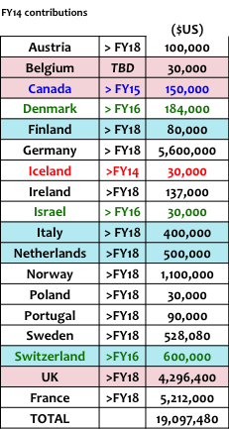

At the moment ECORD has 17 member countries. Iceland has withdrawn from ECORD at the end of 2014. Most of the countries are committed until FY18. Denmark, Israel and Switzerland are committed until FY16, and Canada until FY15. A timing for the procedures for the ECORD renewal post-FY18 will be proposed at the next ECORD Executive meeting in March 2015.

The contribution of Belgium is secured for FY15 at 25,000 € (J.-P. Henriet).

Within the next weeks ECORD will face some problems due to currency exchange rates. Currency fluctuations will be a problem for countries paying in € or £ (G. Camoin).

There are renewed contacts with Spain showing that they could maybe come back to ECORD. New contacts with J. Thiede regarding Russia reveal some promising contacts with Russia. For example, O. Petrov will attend the next EFB meeting in March 2015. A good starting point for the contribution of Russia would be $500,000 USD plus in-kind contributions (IKCs, G. Camoin). There are still contacts with the Czech Republic and Luxembourg and new contacts with Turkey. This year Turkey probably wants to organise an IODP Day and the Turkey Ministry is positive about an ECORD membership.

**ECORD budget**

FY14 ended with a positive balance of $8,220,869 USD (Table 2), which was carried over to FY15. There is the same level of contributions in FY15, however, we might loose some money due to currency exchanges. This is the case for countries like France paying in euros and that might loose ca. 20%. ESO FY15 expenses include the implementation of the Atlantis Massif Expedition. FY15 should finish with a positive balance of $11,978,792 USD (Table 3). Additional contributions are not considered in this calculation. For example, the UK will provide a ship and ship time for the Atlantis Massif Expedition.

Table 2: ECORD FY14 budget Table 3: ECORD FY15 budget





G. Camoin continued to present the predictions for the budget FY16 and beyond (Table 4). The table is based on cash and potential additional contributions like IKCs are not considered. FY16 should finish with a positive balance of $11,236,000 USD after the implementation of the Chicxulub Expedition that will cost $8.5M USD. After implementing an Antarctic expedition for $6.7M to $12.5M USD in 2017, the FY17 should finish with a positive balance of $6,446,000 to $12,246,000 USD. In FY18 $14,156,000 to $19,956,000 USD will be available for ESO and the range for an Arctic expedition will be between $21M and $29M USD.

Table 4: ECORD budget FY16 and beyond

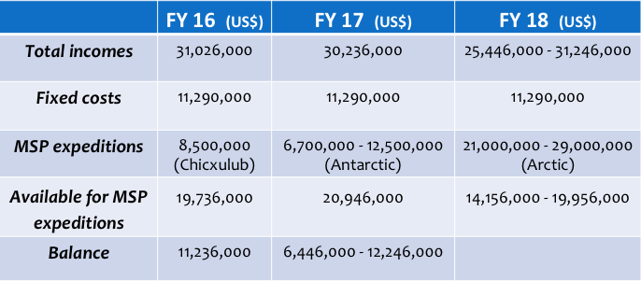

DISCUSSION on the budget table FY16 and beyond:

The costs of the Arctic expedition include the icebreaker support (D. McInroy). According to an agreement with the US, there could be an IKC for the Arctic in 2015 and 2017, and this could also be possible for 2018 (M. Friberg). They could do some site survey in western Greenland in 2015 and in the High Arctic in 2017. It could be possible to change the Arctic and Antarctic expedition (G. Camoin/K. Gohl). There is no difference for the EFB and the budget, and icebreaker support for 2017 would be welcome (K. Gohl). Only an additional site survey is possible in 2017 but icebreaker support could be possible in 2018, better 2019 (M. Friberg). For an expedition in FY17, a vessel has to be contracted in FY16. In order to sign a contract for a vessel, ESO does not need the money in the bank in FY16, but an amendment with the CNRS guaranteeing the money for ESO (D. McInroy). This research agreement has to be done one year before the expedition (D. McInroy). The money should be available in May/June 2017 for an expedition in 2018 (G. Camoin). However, in autumn 2017 not the complete amount of money might be available for an Arctic expedition in 2018 (M. Webb). But with a written letter ECORD can guarantee getting the money from at least the three big contributors France, Germany and UK who are committed until FY18 (G. Camoin).

Expedition costs for the Antarctic might be reduced by IKCs (M. Webb). For example, the *Polarstern* 2 and the new UK polar ship are capable deploying rock drills (M. Webb). Furthermore, the new UK polar ship is available from 2019 (M. Webb) and the *Polarstern 2* is available from 2019 or 2020 (G. Camoin/K. Gohl). The estimated expedition costs for the proposal 813 (Antarctic) are $10.5M USD excluding ESO fix costs and assuming full costs for the US icebreaker *N. B. Palmer*.

* **ACTION (G. Camoin)**: to update the budget table FY16 and beyond for the EFB meeting in March 2015 with the new ESO estimates of the expedition costs.

G. Camoin explained the system of the IKCs and the Amphibious Drilling Proposals (ADP). One example for an ADP in the system is ADP-796 by A. Kopf: Landslide geohazards – testing multiple trigger mechanisms at the Ligurian slope. The system of the ADPs is a good progress in the ICDP-IODP collaboration. ECORD and ICDP allocate 10,000 € each per year for the workshops dedicated to the submission of ADPs.

Substantial interest is available on the money in the bank (M. Webb/G. Camoin) that could be used to pay, for example, the ESSAC budget.

# 4 – ESO: Scoping/tender process, operations, technical developments (D. McInroy)

(9:52)

D. McInroy presented the upcoming Expedition 357: Atlantis Massif (2015) including the associated seafloor drill developments and the IKCs from the UK. Furthermore, he reported on Expedition 364: Chicxulub (2016), the IODP Proposal #813: Antarctic Cenozoic Paleoclimate (2018) and MSP proposals at the EFB and at the SEP.

**Expedition 357: Atlantis Massif**

RRS *James Cook* is secured as an IKC from the UK with a value of $1,985,600. The sailing dates are from 24th October to 9th December. The Onshore Science Party provisionally starts 20th January 2016 for three weeks.

The Atlantis Massif Expedition was used to develop new systems and tools, e.g. new logging tools, a borehole packer system, a drill string plug for post-expedition fluid sampling, a drill-mounted tracer delivery system, a drill-mounted water sampling system and a drill-mounted sensor package. At the end of August 2015 there will be a full wet test for all systems offshore Scotland.

NERC has recently changed its ship-funding model, that means users now pay variable costs. Variable costs were assumed to be part of the IKC. The actual cost of the IKC to NERC is $1,985,600 and represents ca. 60% of the offshore expedition cost. According to ESO, RSS *James Cook* as an IKC should attract the maximum of three berths.

DISCUSSION on the number of berths for the UK IKC RSS *James Cook*:

The maximum number of Science Party positions is 32 and the three extra berths are for the Science Party and they might not necessarily be on the ship (D. McInroy). If there are three additional berths, there might not be three additional scientists. The extra berths can be used as a mitigation system for the quota. One berth can be a compensation because the UK is overquota at the moment (G. Camoin).

* **ACTION (G. Camoin)**: to discuss with G. Früh-Green to have two new scientists on the Science Party for the UK IKC RSS *James Cook* and to take one or two as a compensation for the overquota of the UK.

**ECORD Council Consensus 15-03-03**:

The ECORD Council approved three extra berths for the UK in-kind contribution RSS *James Cook* for the Atlantis Massif Expedition.

DISCUSSION on platform availability using two drills during Expedition 357:

The RSS *Discovery* could not have both drills at the same time. Only the RSS *James Cook* could deliver it for the Atlantis Massif Expedition (M. Webb). But there are also two or three German and one or two French vessels which could have both drills (G. Camoin). Both drill systems can be tested in this environment and it can be seen as a security backup in case of one system fails (K. Gohl). This will not be a model that will occur more often in the future (K. Gohl). The two systems need a huge engineering team (D. McInroy). Vessels using the MeBo200 will need adaptation (G. Camoin). Depending on the scientific objectives MeBo70 and MeBo200 will be used (G. Camoin). G. Camoin points out the importance of an open call to make sure that the vessels are available.

**Expedition 364: Chicxulub Impact Crater**

Negociations with the preferred contractor started. The project was descoped from two holes to one hole with trying to reach 1500 mbsf while staying within the budget. The minimum was 1200 mbsf so that the objectives could be met. It will be a 70 day operation but it could be less. The current expedition cost estimate is $9.9M USD and does not include the ESO planning costs of about $2M USD. The EFB set a limit of $8.5M USD and ICDP has provisionally awarded $1M USD. To sign the contract ESO needs the platform funds of $7.6M USD by early summer of an amendment from ECORD/CNRS guaranteeing the funds (D. McInroy). The money should be available until summer (G. Camoin).

DISCUSSION on the costs of Expedition 364:

There is a concern of how deep has to be drilled to reach the scientific objectives and if more money should be made available to continue drilling if the science plan is not yet met (M. Webb). It is possible to make a quick status report on the physical properties of the material and from the type of material they know in which regime they are and then they can set a limit (K. Gohl). The decision point at which the expedition should be stopped can be discussed with the proponents (D. McInroy).

At the end of the month D. McInroy will discuss a Mexican contribution. The Mexicans could provide a supply vessel or perhaps some hard cash. In case of an IKC ECORD has to consider some extra berths for Mexico (G. Camoin). The ECORD Council approved an upper limit of $8.5M USD and if more money is needed then the EFB has to dicuss again (G. Camoin). The $0.4M USD can be solved with the Mexican IKCs. In the next probably two months ECORD will know if the $8.5M USD are enough (D. McInroy).

The money from ICDP comes on top of the IODP money and the Co-chiefs have to write an addendum to ICDP on how to use their money on this expedition (D. McInroy). ICDP will be a co-sponsor for this expedition.

The present market situation with respect to the low oil price has no big effect on the quotes ESO gets. The costs are only slightly lower (D. McInroy/K. Gohl).

The costs of Expedition 364 will be rediscussed at the next Council Meeting in October 2015 when there are better cost estimates from ESO and when ECORD will know more from ICDP and Mexico.

**IODP Proposal #813 Antarctic Cenozoic Paleoclimate**

The only possibility so far is to contract the *N. B. Palmer* that is potentially available in February to April 2018 and not 2017 as directed by the EFB. However, the ship is not provided as an IKC. The expedition cost estimate is $10.5M USD not including the ESO fixed costs of ca. $2M USD. The last cost estimate was $6.3M USD which assumed an IKC of the ship.

DISCUSSION on the costs of Proposal #813:

The mobilisation and transit costs $2.5M USD and the remaining costs are for the ship running the expedition (D. McInroy). The *N. B. Palmer* seems to be the only choice at the moment (G. Camoin/D. McInroy). There are other icebreakers but they do not operate in this area (D. McInroy). The EFB should revisit the 5-year schedule because for the visibility of ECORD it is important to implement one expedition in 2017 (G. Camoin). K. Gohl highlights the problem of the payment of the full costs for a research vessel by IODP/ECORD. The model for the RSS *James Cook* is acceptable because ECORD does not have to pay the full costs. However, it is not acceptable that IODP/ECORD has to pay the full costs for the *N. B. Palmer* (all). The expedition cost estimate of $10.5M USD is too high. It is the right moment to convey a message to the US colleagues and the NSF regarding this issue (G. Camoin). There could be an alternative to this expedition (M. Webb/K. Gohl). M. Friberg suggested to downscale the project due to the high costs. However, it is good to drill transects. The problem is the very long transit, staying in the area for one more week does not make a difference (K. Gohl). There might be also the strategy to put this expedition on hold until the ship is in the right region (M. Webb).

ECORD needs a full picture of the collaboration with NSF and not only the high costs of this expedition (M. Diament). ECORD should have a high-level discussion with the NSF Polar Program and look into the future with the infrastructure.

(10:52)

coffee break

(11:15)

**MSP proposals at the EFB**

D. McInroy presented the four MSP proposals that are currently at the EFB:

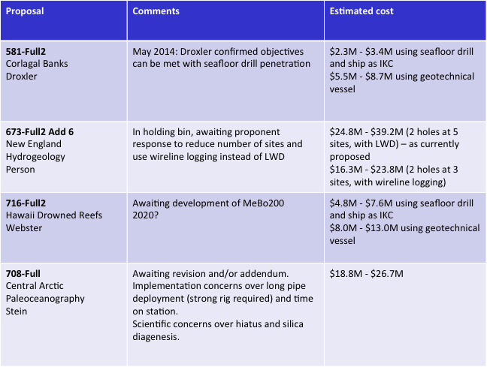

**581-Full2** will be a short expedition with 15 days maximum. Using a geotechnical vessel is not efficient because the mobilisation costs will be disproportionally large compared to the expedition costs. A. Droxler confirmed that a seafloor drill would reach the scientific objectives and that a penetration between 50 and 70 m is fine for his proposal.

Proposal **637-Full2 Add6** is in the holding bin and a quite expensive MSP expedition. The proponents consider to reduce the number of sites and to use wireline logging instead of logging while drilling.

The proposal **716-Full2** is awaiting the development of the MeBo200. According to T. Freudenthal the first real scientific project for the MeBo200 will be offshore New Zealand in 2016 (D. McInroy). At the moment the MeBo200 is not ready to be released for IODP purposes.

INFORMATION on the MeBo (G. Camoin):

The first possibility to drill with the MeBo70 or MeBo200 will be in 2020. At the moment there is only one technical team for the MeBo and they do not have the money to get two teams. In addition, there is a delay because two German MeBo expeditions were cancelled due to ship problems and they can only implement two expeditions per year with the MeBo.

DISCUSSION on requirements for US waters:

There are difficulties for sites in US waters. No foreign vessel is allowed to drill in this US economic zone. For example, for New Jersey a US platform had to be used (J.-P. Henriet). It is important to check the legal restrictions. There are expensive requirements for US waters (M. Webb).

For the proposals 581-Full2 and 716-Full2 the use of a seafloor drill plus a regular research vessel could be an option between the use of a seafloor drill plus a ship as an IKC and the use of a geotechnical vessel (M. Webb). The costs to charter a chip will be inbetween but probably closer to the geotechnical option (D. McInroy).

Proposal **708-Full** will be revised.

**MSP proposals at the SEP**

D. McInroy reported on the MSP proposals at the SEP. The full proposal **852** will be probably submitted in April 2015 and should have a CPP element attached. There is also potential for IKCs for expedition 852. The proposal **860-CPP** was not rejected by SEP for scientific reasons. SEP could not consider this proposal as a CPP. This could even be a new model for proposals and this issue about collaborations with different programs has to be discussed at the next IODP Forum (G. Camoin). This proposal was not in the spirit of IODP. For the future another category, a partnership program category, is needed for proposals where IODP is one partner (K. Gohl). However, NSF does not want to change the proposal categories until the end of the current phase. Proposal 860-CPP should have been a science support issue and it should not have been sent to SEP (G. Camoin). Proposal **867-Pre** was rejected due to safety issues (K. Gohl).

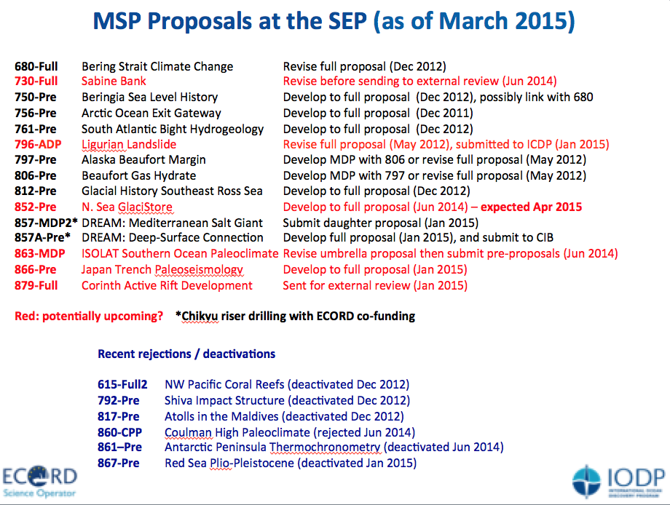

# 5 – Mid to long-term MSP scheduling (K. Gohl)

(11:36)

K. Gohl gave an overview of the MSP proposals at the EFB. Three proposals are scheduled: 548, 758 and 813. Proposal 813 has to be discussed at the next EFB Meeting. The proposals 581, 637 and 716 are in the holding bin and the proposal 708 is not yet decided. The proponents of proposal 708-Full will probably submit an addendum next week and ESO will update the cost estimates within a week.

# 6 – Overview of active MSP proposals (K. Gohl)

(11:46)

K. Gohl gave an overview of active pre- und full proposals at the SEP.

**MSP 680-Full**: Bering Strait Climate Change

This expedition is in the medium to high cost category. The current status (12/2011) at the SEP is the submission of a revised proposal and to probably link this project with proposal 750. But so far there is no progress. A. de Vernal commented that there are difficulties with the ship time on the US and Canadian side to complete the site survey.

**MSP 730-Full**: Sabine Bank & Bougainville Guyot Sea Level

This expedition is in the low cost category. In 06/2014 SEP recommended the revision of the full proposal. There are still issues with the site survey data and the availability of the MeBo200. With penetration depths of up to 200 m this proposal would be a good target for the MeBo200.

**MSP 750-Pre**: Beringia Sea Level History

This expedition is in the cost category between low and high. This could be a combined MSP-*JR* expedition. The current status (12/2011) at the SEP is the submission of a full proposal and to probably link this project with proposal 680.

**MSP 756-Pre**: Arctic Ocean Exit Gateway

This proposal is in the high cost category. For this expedition icebreaker support would be needed .The current status at the SEP (12/2011) is the submission of a full proposal.

**MSP 761-Pre**: South Atlantic Bight Hydrogeology

This expedition could be possibly done with the MeBo200 and the costs would be in the low to medium category. The current status (12/2011) at the SEP is the submission of a full proposal.

**MSP 796-Full**: Ligurian Landslide / ADP: Nice Amphibious Drilling

The expedition is in the low ECORD cost category. The drilling will be done in shallow water depths and with shallow penetration depths. Therefore, the idea is to use the same drill rig onshore and offshore. In 05/2012 the recommendation by SEP was the revision of the full proposal. The proponents submitted an ADP to ICDP in 01/2015. By summer the guidelines for ADPs will be finalized. A workshop should be recommended but not required.

**MSP 797-Pre**: Alaska Beaufort Margin

This expedition is in the low to medium ECORD cost category. The current status (05/2012) is the submission of a full proposal.

**MSP 806-Pre**: Beaufort Gas Hydrate

This expedition is in the low to medium ECORD cost category. SEP recommended to merge this project with proposal 797 or to write a multiple drilling platform proposal.

**MSP 812-Pre**: Ross Sea Glacial History

This expedition could be done with the MeBo or RD2 system and it is in the low cost category. The current status (12/2012) is the submission of a full proposal.

**MSP 852-Pre**: North Sea GlaciStore

This is a medium to high cost ECORD expedition that has societal relevance in terms of CO2 storage reservoirs. SEP discussed if this could be a CPP because industry is already involved in this proposal. Industry is interested and could supply a lot of data. In 06/2014 SEP recommended the submission of a full proposal.

**857-MDP2**: DREAM Mediterranean Salt Giant and **857A-Pre**: DREAM-GOLD Giant Saline Basin

This high-cost expedition can be only done by the *Chikyu*. ECORD would fund a maximum of $10M USD (G. Camoin). The CIB decided that this should be a CPP. The total costs would be $110M USD (G. Camoin). The proponents have to get in contact with industry to get 70% of the total costs (G. Camoin).

**MSP 863-MDP**: ISOLAT Southern Ocean Paleoclimate

This proposal is in the low ECORD cost category. For this multiple drilling platform proposal various research vessels are asked to carry the long-piston coring system and to deploy it in various sites around the Southern Ocean. In 06/2014 the proponents were asked to submit daughter proposals. They will submit the proposals this year (G. Camoin).

**MSP 866-Pre**: Japan Trench Paleoseismology

This expedition is in the low ECORD cost category. It can be done without the *Chikyu* and a Japanese vessel can be probably used as an IKC. In 01/2015 SEP recommended the submission of a full proposal.

**MSP 879-Full**: Corinth Active Rift Development

This expedition is in the medium to high ECORD cost category. In 01/2015 this proposal

was sent to external review.

DISCUSSION on the mid- to long-term planning of expeditions:

There is a good mix in cost categories and science plan themes of the active proposals (G. Camoin). Regarding the mid- to long-term planning it would be important to get very soon in contact with the Marum in Bremen in order to ask for the use of the MeBo and to book it already (M. Webb/K. Gohl). At the same time ECORD has to ask the operators of the research vessels to make a reservation (K. Gohl). The problem is that most of the European fleet gets planned on a 12- or 24-months time scale (M. Webb). After the EFB Meeting in March 2015 ECORD will get in contact with the Marum in Bremen in order to book the MeBo for future MSP expeditions.

The proponents will submit the full proposal 852 (North Sea GlaciStore) in April and it should be a CPP. There is also a strong potential for an IKC, perhaps with the hazard site survey (D. McInroy).

DISCUSSION on ADPs:

J.-P. Henriet was asking if the ADPs are delaying or complicating the system. G. Camoin commented that it is still possible to submit proposals for drilling only on land or only at sea. According to A. Kopf it helps a lot to have the land-to-sea concept which was not in the system before. The ADPs will be reviewed by a joint ICDP-IODP panel (G. Camoin). The system is not more complicated and according to the definition a proposal is an ADP when the scientific objectives can only be reached by drilling both on land and at sea (G. Camoin). We need integrated studies onshore and offshore (M. Diament).

Sweden has a drill rig that can drill down to 3000 m. It was tested on land and it can also be put on a ship to drill in shallow waters. This drill rig was bought from the Swedish Research Council and there is open access for scientists. Information can be found on the website of the Swedish Scientific Drilling Program (SSDP).

(12:35)

lunch break

(14:34)

# 7 – MSP proposals to be discussed at the ECORD Facility Board meeting #3 (K. Gohl)

K. Gohl explains the EFB budget table for MSPs from 2014 to 2018 (Table 5). A medium- to long-term strategy for scheduling is needed because of variations in the budgets and costs and because of the availability of ships and equipment.

Table 5: EFB budget calculation table for MSPs (status: 12 March 2015).

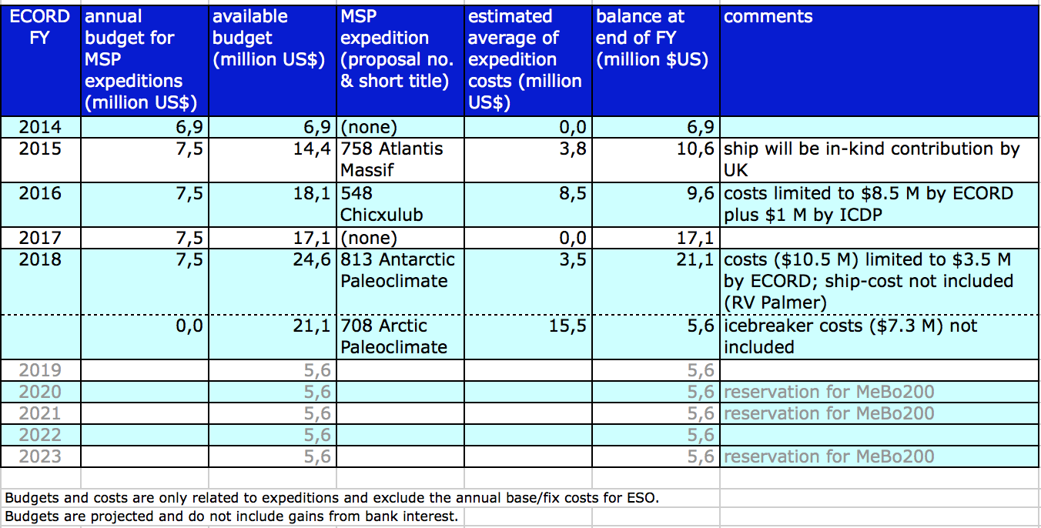

The table shows the available budget per year, the estimated average expedition costs of the scheduled expeditions not including the ESO fixed costs and the balance at the end of the respective FY. On average $7.5M USD are available per year for an MSP expedition. G. Camoin commented that the annual budget available for MSP expeditions is $7.7M USD. The average costs for ECORD of the expeditions 758 Atlantis Massif in 2015 and 548 Chicxulub in 2016 are estimated to $3.8M and $8.5M USD, respectively. There was no expedition in 2014 and no expedition is scheduled in 2017. However, another low-cost expedition could be added in 2017. Expedition 813 Antarctic Paleoclimate is planned for 2018 due to the *N. B. Palmer* availability. However, the costs for Expedition 813 are $10.5M USD including the *N. B. Palmer* costs instead of only $3.5M USD. The average estimate for Expedition 708 is $15.5M USD without icebreaker costs. However, the drill rig costs for the Arctic are difficult to estimate (D. McInroy).

DISCUSSION on the EFB budget table for the MSPs from 2014 to 2018:

It was suggested to extend the MSP expeditions planning for a couple of more years at the next EFB Meeting in March 2015 including different scenarios for the next years (K. Gohl). On a midterm scale, i.e. for the next three years a firm scheduling should be done so that ESO can plan the expeditions (G. Camoin). Furthermore, three additional years should be added for long-term planning indicating a low, mid or high cost category but not giving a proposal name or number (G. Camoin). It is important not to cancel an expedition just because it is too expensive but a limit has to be set to the amount of money ECORD can spend for a certain expedition (M. Friberg). This was already done with the Chicxulub Expedition. A cap of $8.5M USD was put on this expedition (K. Gohl). The implementation of low and high costs MSP expeditions have to be balanced in order to avoid a year without any expedition (M. Webb). At this point it is important to highlight the importance of the IKC system that has to be developed (G. Camoin).

The costs for **Expedition 813**: Antarctic Paleoclimate have to be reduced (H. Roggen). Therefore, a discussion with NSF is needed in order to reduce the costs for the *N. B. Palmer* (G. Camoin). The problem of the high costs for the *N. B. Palmer* for Expedition 813 should be discussed at the next EFB (G. Camoin). At the last EFB meeting the cost estimate for Expedition 813 was between $4.7M and $5.9M USD, i.e. between $2.7M and $3.9M USD not including the ESO planning costs and assuming that the ship is free (D. McInroy). A maximum of $6M USD was set including the ESO running costs: $3.5M plus $2.5M USD ESO costs (G. Camoin/D. McInroy). The costs of the *N. B. Palmer* are close to $7M USD with $2.3M USD for mobilisation and demobilisation and the daily costs are $77.500 USD adding up to $4.6M USD (D. McInroy). ECORD should not consider an upper cap of only the seabed drill costs because this is based on a pure IKC from the US and the US are not interested by the IKCs (G. Camoin). They have already 8 US scientists on MSP expeditions and they do not need more because this would cause only additional costs for them. An intermediate number between the pure IKC and their costs has to be discussed (G. Camoin).

A year when using the **MeBo200** should be already fixed and the MeBo200 should be reserved (K. Gohl). The MARUM wants to have a long-term planning. However, the earliest booking for the MeBo can be done in 2020 (G. Camoin). It could be good to book the MeBo twice, for 2020 and for 2023 (M. Webb). The equipment and the consumables for the MeBo200 are a bit more expensive than for the MeBo70 but the number of technicians is the same (K. Gohl/D. McInroy). The MeBo70 has a daily rate of ca. 13,800 € plus mobilisation (full costs) and the in-house (collaboration) costs are at a daily rate of 6,600 € (K. Gohl). The MARUM will change its basic funding model in 2017, i.e. they have to attract external funds to help funding their equipment and they will probably look for industrial contracts (K. Gohl).

* **ACTION (EFB)**: to contact the MARUM in Bremen in order to book the MeBo200 for the years 2020 and 2023.

ECORD has to deliver four MSPs by the end of 2018 and it could be problematic to have only three MSPs in the first five years of the programme (M. Webb). There has to be one priority expedition in the first five years, i.e. the Artic expedition is scheduled in 2018 (K. Gohl). To implement the Arctic expedition in the first five years of the programme, or at least to firmly schedule this expedition, is important for the ECORD renewal process (G. Camoin). The renewal is in 2018, i.e. the report has to be done in 2017 and at this time the Arctic expedition will not be implemented. That means it does not make a difference if the Arctic expedition is scheduled in 2018 or 2019 (G. Camoin). It is important to show the funding agencies and the partners that ECORD implements one MSP per year (G. Camoin). The Arctic is the most expensive expedition and ECORD has to work on co-funding, i.e. cash or IKCs, for this expedition (G. Camoin).

In **2017** a cheaper expedition could be scheduled but ECORD should not wait more than six months from now for a firm scheduling (D. McInroy). ECORD should get in contact with the proponents of Expedition 813 in order to set a limit for the expedition costs and at the same time the EFB should look for alternatives for an expedition in 2017 (D. McInroy). An alternative could be Expedition 581: Coralgal Banks that costs $2.3M to $3.4M USD not including ship costs (D. McInroy). A decision on scheduling a low-cost expedition in 2017 has to be done at the next ECORD Council Meeting in October 2015.

* **ACTION (EFB)**: to send a message to the proponents of Expedition 813: Antarctic Paleoclimate that the vessel, the *N. B. Palmer*, for their expedition cannot be paid by ECORD.
* **ACTION (ESO)**: to find out until the next ECORD Council Meeting in October 2015 what options there are for ships for Expedition 581: Coralgal Banks in 2017.
* **ACTION (EFB)**: to decide at the next EFB Meeting in March 2015 on two to three different scheduling scenarios that can be finalized later based on the availability of vessels and the estimated expedition costs.
* **ACTION (EMA + ESO)**: to make a call after the EFB Meeting in March 2015 for IKCs for the 2-3 potential scheduling scenarios.
* **ACTION (EFB)**: to have a Virtual EFB Meeting before the ECORD Council Meeting in October 2015 regarding the various scheduling options and the cost estimates provided by ESO and to provide more accurate numbers to the ECORD Council in October 2015

There is an Arctic Meeting in April 2015 where operators for Arctic and Antarctic expeditions participate (M. Friberg).

* **ACTION (D. McInroy)**: to get in contact with organisations/operators for Arctic and Antarctic expeditions.

Three options for the scheduling of MSP expeditions from 2014 to 2018 can be summarized:

**Plan A**: to follow the schedule in Table 5 and to ask NSF to reduce the costs for the *N. B. Palmer*;

**Plan B**: to replace Expedition 813: Antarctic Paleoclimate with a low-cost expedition, for example Expedition 581: Coralgal Banks;

**Plan C**: to shift Expedition 708: Arctic Paleoclimate by one year.

# 8 – ECORD partnership (G. Camoin / All)

**(« Tour de table » regarding the future of IODP and ECORD)**

## NAS report on Sea Change: 2015-2025 Decadal Survey of Ocean Sciences

(15:27)

G. Camoin presented the NAS report on Sea Change: 2015-2025 Decadal Survey of Ocean Sciences. The key points in this report are:

1. « IODP has implemented many cost-savings measures in recent years to decrease operating costs and improve efficiency. »
2. « NSF … is strongly urged to pursue a more cost-effective partnership. »
3. « one budget solution could include a reduction in the total number of platforms operated by members of the consortium »
4. « NSF plans to fund IODP (2013-2018) at a total of $250M over the next five years, providing for four *JOIDES Resolution* expeditions annually. »
5. « the frequency of ECORD mission-specific platform operations, originally intended to average one per year according to the past two IODP science plans, has not been realized. In contrast to these optimistic plans, between 2004 and 2014 just five mission-specific platform operations occurred. »
6. « If three drilling platforms are maintained, the committee urges NSF to evaluate whether the subscription costs for international partners to sail on the *JOIDES Resolution* are appropriately priced. »

The recommendations from the committee are:

* to reduce the O&M costs of the major infrastructure (OOI, IODP and the academic research fleet) and restore funding to core science and OTIC within the next five years
* to reduce immediately 10% in major infrastructure costs, followed by an additional 10-20% decrease over the following five years
* to distribute the immediate initial 10% cost reduction in major infrastructures (OOI 20%, IODP 10%, research fleet 5%)

A cut of 10% for IODP means approximately $5M USD a year.

The committee considers four different scenarios:

1. Raise more revenue from international partners

2. Increase external funding for operations

3. Reduce costs for operations by reducing program-funded science services

4. Reduce the number of expeditions per year

Item 1 is also linked to the fact that Brazil reduced its contribution to the programme from $3M to $1M USD due to the oil prize (G. Camoin). India plans to increase its contribution from $1M to $3M USD and China wants to increase from $3M to $6M USD. Regarding item 2, it is planned to increase the number of CPPs (G. Camoin). Item 3 is not favored by NSF at the moment because the costs savings are likely to be too small (G. Camoin). Item 4, the reduction of four expeditions to three is unlikely (G. Camoin). NSF will listen to the first two recommendations (G. Camoin).

DISCUSSION on the NAS report on Sea Change: 2015-2025 Decadal Survey of Ocean Sciences:

Comment 5 is unfair and we should have a stronge response to this (K. Gohl). For the new Science Plan ECORD committed for one expedition per year on average, however, the whole system was set up just before the new science plan phase started and there was no time to already organise an expedition in 2014 (K. Gohl). When the business plan was finalised ECORD did not know how much money will be given to the NSF (D. McInroy). In the previous phase ECORD was not committed for one MSP expedition per year and ECORD was paying $14M USD for the *Chikyu* and the *JOIDES Resolution* (G. Camoin/D. McInroy). If we come back to a system that we had during the previous phase, i.e. to implement one MSP expedition every two years and to provide money to the *JR*, then probably not all funding agencies will be ready to go beyond 2018 with ECORD (G. Camoin). There is a recommendation from a panel in Germany on these issues that ECORD should try to support the NSF and to keep the *JR* available for European scientists, but ECORD should also keep its independence (G. Lüniger). Furthermore, the report does not mention that ECORD paid every year its contribution but did not get the number of expeditions it paid for when the *JR*  was refurbished, (G. Camoin). ECORD should react to this report and send a letter mentioning that in the last programme phase NSF also did not deliver what they proposed and that ECORD has paid a significant amount of money for the *JR* (G. Lüniger). This letter should be sent to the Science Board and the NSF (K. Gohl). ECORD has to be careful criticizing the NSF and try to help the NSF (M. Friberg). T. Janecek will give some informations about the report and internal NSF discussions at the next Executive Meeting in March 2015. There is a two-stage approach: 1. to correct the report; 2. to wait for the reaction of the NSF to these recommendations (J.-P. Henriet). The reduction of the IODP programme may also directly impact the support from the governments of the ECORD member countries and the support from the European Commission, i.e. ECORD has to get prepared to have arguments and to decide on how to react to a strong decrease suggested in the report (M. Diament). G. Camoin commented that scenario 1 is directly for ECORD.

* **ACTION (ECORD Council)**: to prepare a response letter to the NAS report on Sea Change: 2015-2025 Decadal Survey of Ocean Sciences and send it to the Science Board and the NSF.

‘TOUR DE TABLE’ on the visibility of ECORD and the number of MSP expeditions per year:

M. Diament (**France**): There will be immediately an important decrease of the French contribution to ECORD, if ECORD responds to the decrease of the NSF funding with providing more money to the US. Furthermore, it will be difficult to keep the French contribution at the same level.

G. Lüniger (**Germany**): The German response will be the same like the French response.

Michael Webb (**UK**): This questions was addressed in a review four to five years ago and the *JR* and MSPs were equal priority. At this time there was one MSP every two years and no pressure to increase it. It was beneficial to increase from one MSP in two years to one MSP every year. A balanced programme in the UK is four *JR* legs a year and one MSP every two years.

H. Roggen (**Norway**): The most important is to increase the participitation of Norwegian scientists. The target areas are more important than the change in numbers, i.e. one or two MSPs per year.

Olga Dias (**Portugal**): ECORD is more visible in the new programme phase compared to the previous one. There are more activities including Portuguese scientists and also teachers.

Anne de Vernal (**Canada**): At the moment there is a proposal under evaluation supporting IODP/ECORD. The Canadian contribution is part of this proposal led by the University of Victoria. This is more for the *JR* than for the MSPs because it is linked to the Cascadia network. The Arctic Ocean is a priority. Canada hopes to contribute with IKCs or real money if there is an expedition that is of relevance. It would be helpful for ECORD if Canada is more involved in EMSO (M. Diament). The University of Victoria is making a link with EMSO (M. Webb).

X. Monteys (**Ireland**): The highest priority is to secure the contribution to ECORD as long as Ireland sends scientists with the *JR*, MSPs or any other platform. There is an interest to increase the number of MSP expeditions to a maximum, i.e. prioritizing the low-budget MSPs.

J.-P. Henriet (**Belgium**): On a long-term view the *JR* will be most likely gone in 20 years from now while the flexible MSP concept may stay. There are plenty available platforms and ECORD is doing well with its visibility. There is a Belgium drilling platform that can drill the shelfs down to 100 m.

M. Friberg (**Sweden**): Sweden is committed to five years and there is no problem to continue contributing to ECORD. The priority is the Arctic after the implementation of the Baltic Sea Expedition. A new ROV was developed but it is going more towards using things which are already there rather than building new things.

A. Kjaër (**Denmark**): Denmark is in a 3-year circle, i.e. starting this year the interests and what has been done have to be discussed again. The Baltic Sea Expedition was quite successful from the perspective of Denmark. Denmark will be in the programme if an Arctic expedition is scheduled. The number of expeditions is less important than the target areas.

M. de Jonge (**Netherlands**): There are new budgetting rules from the Department of Education with an obligation to spend more money on partnerships and industry-related research and there is a drop in basic research by half. The Foreign Affairs Ministry is strongly supporting Arctic Research, i.e. it would be good if ECORD implements an Arctic expedition and if ECORD has industrial partners. The amount of money for funding basic research has dropped but not the money in the system.

The ‘Tour de Table’ discussion has shown the importance of an Arctic expedition. If the costs for the Arctic expedition can be reduced, it could be possible to implement a low-cost expedition in addition (G. Camoin). ACEX-2 is of importance for the visibility of ECORD (J.-P. Henriet) and and for the ECORD renewal process (G. Camoin).

(16:20)

coffee break

(16:43)

## Status of the *Chikyu* expeditions and MEXT funding

G. Camoin presented the scheduling of the *Chikyu* and the funding situation in Japan.

CDEX struggles budgetary constraints because:

* JAMSTEC could not carry over its cumulated profits between Five-year programs of Independent Administrative Legal Entity in April 2014.
* A couple of non-IODP operations were cancelled.
* BOP and ship body inspection needs more cost than expected.

The Japanese do not exchange money with the US. There are only berth exchanges. The Japanese have external funds of only $1.3M USD per year. The regular members are ECORD with $1M USD per year and ANZIC with $300,000 USD per year. In 2012 and 2013, the government funded $97M USD (= 73% of the total costs for operating the *Chikyu*) and they got $36M USD (= 27% of the total costs for operating the *Chikyu*) coming from commercial works. The total expense they had to face was $133M USD. At this time they could conduct IODP drilling in 2012 and in 2013. In 2015 they have to face costs of more than $40M USD concerning the maintainance of the *Chikyu*. Furthermore, they are not allowed anymore to carry over funds from previous periods and there are some budget cuts by the Japanese Government. Just to maintain the *Chikyu* without any expedition they need $70M USD every year, i.e. if they want to drill they have to find additional money. They have $1.3M USD from the partnerships and usually the Japanese Government pays $20M USD for an IODP expedition. This is usually not enough to implement riser drilling. At the last CIB Meeting in July 2014 the following *Chikyu* long-term planning was presented:

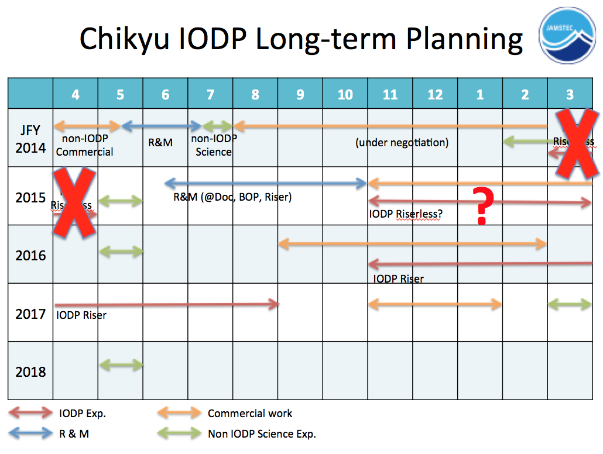

At this time they planned to finish the NanTroSEIZE project in 2016 and 2017 and before that they wanted to implement two riserless expeditions: one between JFY14 and JFY15 and a second expedition probably in JFY15. The first riserless expedition was already cancelled and there are no news about the second planned riserless expedition. There will be more information by the end of the month of the CIB Meeting in Yokohama (G. Camoin).

DISCUSSION on the *Chikyu* situation:

Last year ECORD already paid $1M USD and no expedition was implemented. For this year the Japanese will request the money right now because the JFY starts on April 1st but no expedition is planned (G. Camoin). The Japanese always say that they will catch up with the number of ECORD participants on the next expedition (G. Camoin). The last *Chikyu* expedition was implemented between September 2013 and January 2014 (G. Camoin). The second planned riserless expedition in JFY15 will be also probably cancelled because they will not have enough money coming from the commercial work (G. Camoin). ECORD should not committ for this year because ECORD has no certainty that there will be an expedition (M. Webb). If it would came to a vote, the UK would not give $1M USD to Japan for the *Chikyu*. The agreement with the Japanese is that ECORD provides $1M USD a year under the condition that the *Chikyu* drills for scientific purposes (G. Lüniger). At the moment ECORD should not pay if the Japanese do not deliver but ECORD should not give up this agreement (G. Lüniger). It could be a disaster for the Japanese loosing ECORD as an international partner (G. Camoin). A better approach would be to get extra benefits next time (M. Friberg). $1M USD from ECORD makes no difference for the Japanese, but for ECORD $1M USD is a lot for the expedition budget (K. Gohl). What could be done is to give another berth on an MSP expedition to the Japanese because only the government and not the scientists profit from the payment of $1M USD (K. Gohl). However, if ECORD does not pay $1M USD there will be an impact on the relationship between JAMSTEC and MEXT (G. Lüniger). JAMSTEC will not care about $1M USD but there will be an effect regarding MEXT (G. Lüniger). ECORD should prospone the payment until the status of the second planned riserless expedition is clear (M. Diament). ECORD should hopefully get this answer at the next CIB Meeting (G. Camoin). However, if the Japanese say after the next CIB Meeting that they will definitely drill in September/October 2015 this does not mean a green light for ECORD paying $1M USD (M. Webb). The transfer should be delayed as much as possible (M. Webb). It is important that ECORD announces very early that the agreement is not reached, otherwise ECORD and the Japanese would be in the situation of not trusting each other anymore (M. Friberg). ECORD should clearly state that the situation is not acceptable and if there are no changes then there will be consequences (M. Friberg). G. Camoin will inform the ECORD Council about the real-time situation after the next CIB meeting. Then ECORD should send an official letter coming from EMA and the ECORD Council stating that ECORD has concerns about the situation, whatever the ECORD Council decides on paying or not this year (G. Camoin). It should be mentioned in the letter that there is a strong interest in using the *Chjkyu* in the ECORD science community and that ECORD fully understands the Japanese budget problems, but also that ECORD has concerncs on when the next expedition will be implemented (G. Camoin).

* **ACTION (EMA/ECORD Council)**: to write an official letter to the Japanese stating the concerns about the *Chikyu* situation. It should be mentioned that ECORD paid already twice but that there was no expedition and that ECORD expects a new evaluation of the number of ECORD scientists for the next expedition which is expected to take place in 2016 .

ECORD should still trust the Japanese and should not immediately cut the budget (J.-P. Henriet). But ECORD should make it clear that if there is no expedition in 2015, then ECORD expects a strong presence on the 2016 IODP cruise (J.-P. Henriet). JAMSTEC said that they will catch up with the number of ECORD scientists (G. Camoin). At the moment ECORD has 3-4 berths on each expedition (one berth is for two months), i.e. for a 4-months expedition ECORD would get 6-8 scientists.

The option was suggested to prospone the payment from 2015 to 2016 and to pay $2M USD in 2016 when ECORD knows that there will be an expedition, instead of paying now or cutting the budget (H. Roggen). ECORD should keep the money within the budget and express that ECORD will delay the payment (A. Kjaër). It is a good option to prospone the payment to next year when the plans are firmer and at the same time to request a negociation on the number of berths that ECORD can get on the next expedition (G. Camoin). The MSP budget is tight and if ECORD has to make a hard decision, the MoU with the Japanese would be the first to suffer (M. Webb).

The meeting was closed at 17:20.

# ROSTER

|  |  |  |
| --- | --- | --- |
| ***ECORD COUNCIL*** | ***NAME*** | ***EMAIL*** |
| Austria | Bernhard Plunger* | [Bernhard.Plunger@oeaw.ac.at](mailto:Bernhard.Plunger@oeaw.ac.at) |
| Belgium | Jean-Pierre Henriet | [jeanpierre.henriet@ugent.be](mailto:jeanpierre.henriet@ugent.be) |
| Canada | Anne de Vernal | devernal.anne@uqam.ca |
| Denmark | Anders Kjaër | akj@fi.dk |
| Finland | Anna Kalliomäki* | [anna.kalliomaki@aka.fi](mailto:anna.kalliomaki@aka.fi) |
| France | Michel Diament (Chair) | diament@ipgp.fr |
| Germany | Guido Lüniger (Vice-Chair) | [guido.lueniger@dfg.de](mailto:guido.lueniger@dfg.de) |
| Ireland | Koen Verbruggen* | koen.verbruggen@gsi.ie |
| Ireland (Alt.) | Xavier Monteys (Alt.) | xavier.monteys@gsi.ie |
| Israel | Zvi Ben Avraham* | zviba@post.tau.ac.il |
| Italy | Marco Sacchi* | [marco.sacchi@iamc.cnr.it](mailto:marco.sacchi@iamc.cnr.it) |
| Netherlands | Bernard Westerop* | b.westerop@NWO.NL |
| Netherlands (Alt.) | Marc de Jonge (Alt.) | mr.dejonge@NWO.NL |
| Norway | Heidi Roggen | [hero@rcn.no](mailto:hero@rcn.no) |
| Poland | TBD* |  |
| Portugal | Fernando Barriga* | F.Barriga@fc.ul.pt |
| Portugal (Alt.) | Olga Dias (Alt.) | Olga.Dias@fct.pt |
| Sweden | Magnus Friberg | magnus.friberg@vr.se |
| Switzerland | Martina Kern-Lütschg** | [mkern@snf.ch](mailto:mkern@snf.ch) |
| UK | Michael Webb | [mweb@nerc.ac.uk](mailto:mweb@nerc.ac.uk) |
|  |  |  |
| ***LIAISONS*** | ***NAME*** | ***EMAIL*** |
| EMA | Gilbert Camoin | gcamoin@cerege.fr |
| EMA | Nadine Hallmann | hallmann@cerege.fr |
| ESO | David McInroy | dbm@bgs.ac.uk |
| ECORD FB | Karsten Gohl | Karsten.Gohl@awi.de |

*\* Apologized*

*\*\*Absent*

# LIST OF ACRONYMS

**ACEX**: Arctic Coring Expedition

**ADP**: Amphibious Drilling Proposal

**ANZIC**: Australian and New Zealand IODP Consortium

**BCR**: Bremen Core Repository

**BOP**: Blow Out Preventer

**CDEX**: Center for Deep Earth Exploration

**CIB**: *Chikyu* IODP Board

**CNRS**: Centre National de la Recherche Scientifique

**CPP**: Complementary Project Proposal

**DREAM**: Deep-sea Record of Mediterranean Messinian Events

**EFB**: ECORD Facility Board

**E-ILP**: ECORD Industry Liaison Panel

**ECORD**: European Consortium for Ocean

**EMA**: ECORD Managing Agency

**ESO**: ECORD Science Operator

**ESSAC**: ECORD Science Support and Advisory Committee

**FY**: Fiscal Year

**ICDP**: International Continental Scientific Drilling Program

**IKC**: In-kind contribution

**IODP**: Integrated Ocean Drilling Program (2003-2013) & International Ocean Discovery Program (2013-2023)

**JAMSTEC**: Japan Agency for Marine Earth Science and Technology

**JFY**: Japanese Fiscal Year

**JOIDES**: Joint Oceanographic Institutions for Deep Earth Sampling

***JR***: *JOIDES Resolution*

**mbsf**: meters below seafloor

**MARUM**: Center for Marine Environmental Sciences, University of Bremen

**MeBo:** Meeresboden-Bohrgerät

**MEXT**: Ministry of Education, Culture, Sports, Science and Technology

**MoU**: Memorandum of Understanding

**MSP**: Mission-specific platform

**NAS**: National Academy of Sciences

**NERC**: Natural Environment Research Council

**NSF**: National Science Foundation

**O&M**: Operations and Maintainance

**OOI**: Ocean Observatories Initiatives

**OTIC**: Oceanographic Technology and Interdisciplinary Coordination

**R&M**: Repair and Maintainance

**RD2**: Rockdrill 2

**ROV**: Remotely Operated Vehicle

**SEP**: Science Evaluation Panel

**SSDP**: Swedish Scientific Drilling Program

**TBD**: To be determined