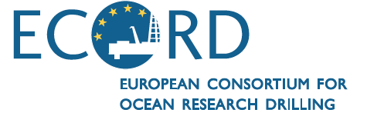

**ECORD Executive Bureau/Vision Task Force Meeting #4**

**Aix-en-Provence, France**

**MINUTES**

***March 24th, 2015***

**TABLE OF CONTENTS**

1 – Self introduction, logistical information and agenda (G. Camoin) 1

2 – ECORD budget summary (G. Camoin) 2

3 – IODP News 5

NAS Decadal Survey report (T. Janecek / All) 5

*Chikyu* funding situation (N. Eguchi / G. Kimura / All) 8

4 – ESSAC News (G. Früh-Green) 10

5 – ECORD-ILP News (A. Moscariello) 14

5 – ECORD post FY18 renewal and ESO & EMA post FY16 renewals (G. Camoin) 16

6 – Update on active MSP proposals (K. Gohl) 20

7 – Procedures for ICDP-IODP joint review of amphibious proposals (K. Becker) 25

8 – Overarching public relations + educational activities (P. Maruéjol/G. Camoin/K. Becker) 28

9 – Next meetings – ECORD attendance (G. Camoin) 30

ROSTER 32

LIST OF ACRONYMS 33

# 1 – Self introduction, logistical information and agenda (G. Camoin)

(9:02)

The host G. Camoin opened the meeting and let all the participants begin self introductions. Then he provided logistical information and gave an overview of the agenda.

**ECORD Executive Bureau consensus 15-03-01**:

The ECORD Executive Bureau approved the agenda of the ECORD Executive Bureau/Vision Task Force Meeting #4.

# 2 – ECORD budget summary (G. Camoin)

(9:10)

G. Camoin presented the ECORD membership (Table 1):

Table 1: ECORD member countries

and their contributions

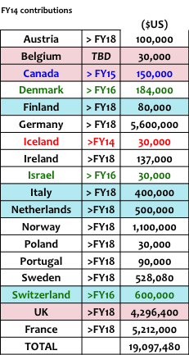

At the moment ECORD has 17 member countries. Iceland has withdrawn from ECORD at the end of 2014. Most of the countries are committed until end of FY18. Denmark, Israel and Switzerland are committed until end of FY16, and Canada until end of FY15.

The current currency exchange rates impact the ECORD budget. Currency fluctuations will be a problem for countries paying in € or £ (G. Camoin).

There are renewed contacts with Spain showing that they could come back to ECORD and there are new promising contacts with the « Accessing Member » Russia through German colleagues. Now there are also important contacts with the academic world in Russia. The new « Accessing Member » status was decided at the last ECORD Council Meeting in Zurich in 2015. If a minimum budget is provided, the « Accessing Member » gets access to educational activities and can attend ECORD meetings as observer, but does not get any sailing scientists on IODP expeditions (G. Camoin).

There are good contacts with Turkey. Three institutes are very interested in joining ECORD and talked already to their Ministry. Turkey is willing to organise an IODP Day in 2015 or early 2016 to hear about the benefits of joining ECORD. Since months there are no news from Luxembourg and the Czech Republic.

G. Camoin continued to present the ECORD budget for FY14 and FY15. The FY14 income is $20,712,660 USD, i.e. $19,097,480 USD from the member contributions and $1,615,180 USD from the FY13 positive balance (Table 2). FY14 ended with a positive balance of $8,220,869 USD (Table 2), which was carried over to FY15. Together with the FY15 member contributions of $19,048,000 USD, the FY15 income yields $27,268,869 USD (Table 3). ESO FY15 expenses include the implementation of the Atlantis Massif Expedition. FY15 should finish with a positive balance of $11,978,792 USD (Table 3). However, due to changes in the currency exchange rates, ECORD could loose $1,528,000 USD. This is because not all countries are paying in dollars. Belgium and France are paying in euros, Denmark in krones and the UK in pounds. In this case, the FY15 positive balance would be $10,450,000 USD. The currency exchange rate at the time of the payment of the invoice counts, i.e. the loss can be calculated after receiving all payments for FY15. Nevertheless, the total fixed costs are $11,290,000 USD every year and $7,710,000 USD are available for MSP operations every year.

Table 2: ECORD FY14 budget Table 3: ECORD FY15 budget



G. Camoin continued to present the predictions for the budget FY16 and beyond (Table 4). The table is based on cash and potential additional contributions like IKCs are not considered. FY16 should finish with a positive balance of $11,236,000 USD after the implementation of the Chicxulub expedition that will cost $8.5M USD. After implementing an Antarctic expedition for $6.7M to $12.5M USD in 2017, the FY17 should finish with a positive balance of $6,446,000 to $12,246,000 USD. In FY18 $14,156,000 to $19,956,000 USD, i.e. $13M to $18M USD taking the currency exchange rate loss into account, will be available for ESO and the range for an Arctic expedition will be between $21M and $29M USD. The implementation of an Arctic expedition appears to be crucial for the ECORD renewal.

Table 4: ECORD budget FY16 and beyond

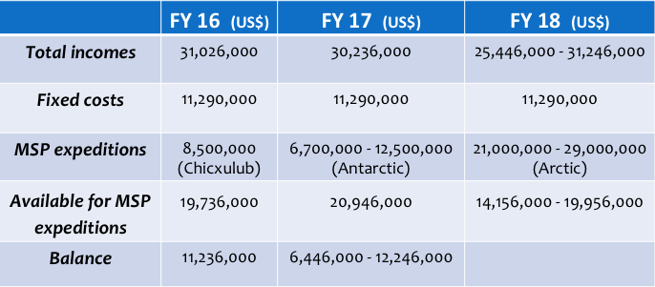

DISCUSSION on the budget table FY16 and beyond:

The cost range of the Arctic expedition is relatively large because the costs depend on which platform will be used and what kind of IKCs could be considered (G. Camoin). If Russia becomes an ECORD member before the Arctic expedition will be implemented and if Russia provides an IKC or cash contribution, the expedition costs could be lowered and this expedition could be made possible (G. Camoin). An Antarctic expedition is less complicated than an Arctic expedition. A different fleet is needed for the implementation of Arctic and Antarctic expeditions. Usually an Antarctic expedition is easier to plan and the cost range is smaller (G. Camoin).

The currency exchange loss results from the four countries not paying in USD, i.e. Belgium (€), Denmark (DKK), France (€) and UK (GBP). For example, ECORD looses $500,000 USD and almost $1M USD because UK and France are paying in pounds and euros, respectively (G. Camoin). To reduce the risk, the UK changed to paying in pounds because NERC paid more than thought every year due to changes in the GBP-USD exchange rate (R. Gatliff). The member contributions can be exactly calculated when the invoices are paid (G. Camoin). Since the beginning of the new programme ECORD gained money. This is the first time that ECORD looses money (G. Camoin). Over the last years the interest was about $400,000 to $500,000 USD every two years when having a couple of millions of USD on the account (G. Camoin). This money can partly compensate the currency exchange loss. Furthermore, the operation costs of vessels must be lower due to the lower fuel prices (K. Gohl). The challenge is to plan the expeditions over the next three to four years. It would be important for ECORD to have always a couple of millions of USD on the account that can be used to mitigate the changes in the currency exchange rates, the fuel costs, etc. (G. Camoin).

Besides the costs for ESSAC (€), all ECORD expenses are paid in USD. The support of the SEP Chair was paid in pounds but these costs will disappear because D. Kroon will rotate off. For simplification, all ECORD activities are paid in USD from the account in dollars (G. Camoin).

# 3 – IODP News

## NAS Decadal Survey report (T. Janecek / All)

(9:33)

T. Janecek presented a brief summary of “Sea Change”, the 2015-2025 Decadal Survey of Ocean Sciences report. Sea Change identified eight decadal science priorities, including: 1) Sea-level change; 2) Coastal and estuarine ocean; 3) Ocean and climate variability; 4) Biodiversity in marine ecosystems; 5) Marine food webs; 6) Evolution of ocean basins; 7) Characterization of geohazards and 8) Subseafloor environment.

One purpose of identifying priorities in this report was to ensure alignment between the next decade’s foremost topics in ocean science and NSF’s investments in ocean research infrastructure. The report assessed how well the current portfolio of NSF-supported ocean research infrastructure matched the decadal science priorities and focused on three major infrastructure assets—the academic research fleet, IODP, and OOI—which together comprise over 50% of the total OCE budget and over 90% of the OCE infrastructure budget.

IODP covers five of the eight Decadal Science Priorities with its relevance with respect to these priorities shown below in Figure 1 (taken from Figure 3-0 in Sea Change report)

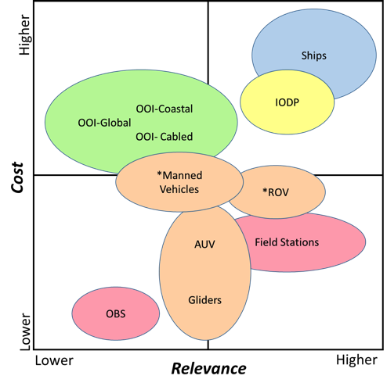 Figure 1: Infrastructure cost vs. relevance

The report provided recommendations to optimize OCE investments that will advance knowledge in the most critical and/or opportune areas of investigation while also continuing to support core disciplinary science and infrastructure. In addition, it provided guidance on the most effective portfolio of investments achievable at the current funding level that will support both the research infrastructure and programmatic science necessary to address the most significant priorities. These recommendations include:

1) Fiscal planning: reduce infrastructure costs if the budget remains flat in order to provide more money to science

2) Rebalancing the budget: adjust the major infrastructure programs to comprise no more than 40-50% of the total annual program budget

3) Immediate and sustained cuts: initiate an immediate 10% reduction in major infrastructure costs, followed by an additional 10-20% decrease over the following five years, and rebalance major infrastructure costs to core science funding within the next five years

4) Distributing the cuts: greatest reduction to OOI (20%), moderate reduction to IODP (10%) and smallest reduction to the academic research fleet (5%)

With respect to scientific ocean drilling, Sea Change provided recommendations to address a 10% cut in NSF-IODP: 1) to raise more revenue from international partners; 2) to increase external funding for operations; 3) to reduce costs for operations by reducing program-funded science services and 4) to reduce the number of expeditions per year. An immediate 10% cut in the NSF *JR* budget would be in FY2016 from $50M to $45M USD.

DISCUSSION on the NAS Decadal Survey report:

T. Janecek informed the ECORD Executive Bureau that NSF-OCE is currently developing a plan to address the recommendations in the Sea Change report. It is too early to formally present this information in detail. The NSF-OCE plan to address the Sea Change recommendations will be made public in early May. However, NSF-OCE is commited to maintaining the current level of expeditions to the extent possible. Thus, in order to address this potential 10% reduction in funding, NSF-OCE will need to discuss with its international partners mechanisms to (1) raise more revenue (perhaps through increases to annual subscription rates to the *JR* Consortium) and 2) increase external funding for operations, perhaps from regular implementation of Complementary Project Proposals, which provide additional funding to the Consortium, or from commercial work.

T. Janecek identified several CPP projects that could potentially be implemented in the next few years if they are forwarded to the *JR* Facility Board from the Science Evaluation Panel. He also noted that if the *JR* implements four expeditions a year, there are still four months per year available for commercial work. However, this kind of work has to be found and the ship has to be in the region where the work is located.

The ECORD Executive Bureau discussed the issue of an increase in partner contributions to the *JR* Consortium. The aspect of the increase in the partner contributions to the *JR* Consortium has to be considered for the ECORD renewal in FY18 (G. Camoin). If ECORD would increase its contribution by $2M-$3M USD then it will be very difficult to implement one MSP expedition per year (G. Camoin). A renegotiation with the ECORD funding agencies would be required (G. Camoin). At the last ECORD Council Meeting in Stockholm in March 2015 there was discussion regarding ECORD’s intention to implement one MSP expedition per year but that in the previous IODP this was not possible. During the previous IODP, ECORD transferred $14M USD to the *JR* each year (vs $7.0M USD in the new IODP) and thus there were insufficient funds to implement one MSP expedition per year (G. Camoin). At the beginning of the current IODP it was made clear that while the *JR* is very important for ECORD scientists, it is also crucial to implement one MSP expedition per year (G. Camoin). This is the visibility that the ECORD funding agencies need. If ECORD does not conduct one MSP expedition per year, it could be very difficult for ECORD to go beyond FY18 (G. Camoin). If ECORD increases its contributions to the *JR* Consortium in the next phase it would have to convince its funding agencies that this contribution to help keeping the *JR* operational is an acceptable trade-off for fewer MSP operations (G. Camoin).

T. Janecek noted that NSF-ODP is also looking for additional international partners but there is nothing definitive at this time.

With respect to industry (non-IODP) funding, T. Janecek told the group that there have been three successful collaborations using the *JR* for commercial work The vessel owner and science operator are free to pursue the use of *JR* for commercial activities when the vessel is not in use for IODP. It will be important for the *JR* Facility Board to consider scheduling models that maximize contiguous blocks of non-IODP to make it easier to conduct commercial operations (and thus provide day-rate relief to NSF). A. Moscariello noted that the impact of collaboration with industry on the public has to be considered. T. Janecek replied that the ship is not owned by NSF and that during times of commercial work there is no relationship to NSF or the international partners.

NSF also pays for Ocean Leadership and the outreach and education part related to IODP (G. Früh-Green). T. Janecek replied that this part of the budget is on the science side and thus not part of the 10% reduction. He also added, that the US Science Support Program (USSSP) will soon be managed by a new awardee. The formal announcement will be made in April 2015.

The Decadal Survey report is from the US point of view (M. Diament). There were no foreign experts in the group writing this report and there are very few connections with the space segment. Neglecting satellites in ocean sciences is surprising and weakens the report (M. Diament). T. Janecek replied that is still a very important report and will be used to help reduce NSF-OCE infrastructure costs and to increase the funding of science.

(10:40)

coffee break

(11:05)

## *Chikyu* funding situation (N. Eguchi / G. Kimura / All)

N. Eguchi presented the funding situation of the *Chikyu*. Every five years the *Chikyu* has to go to dry dock for maintainance. This will be done in mid 2015 and includes a BOP special survey. The maintainance costs are about $40M USD.

JAMSTEC has a five-years mid-term business plan, i.e. a carry over of money from the previous five years is not possible and 2014 started from scratch. JAMSTEC gets funding from the government and this amount is decreasing every year. This government funding is not only for *Chikyu* operations or CDEX but for the entire JAMSTEC operations. That means that the expenditures for the next years have to be decreased. This trend will not change within the near future. In addition, the JPY is depreciated and the crude oil market collapsed. The government fund is provided in JPY but the expenditures are in USD and a 20% weaker JPY makes a difference. The decreased oil price impacts the opportunities for industry work. Even if there is a chance for industry work, the day rate is too low and there is nothing to gain. The overall impact on *Chikyu* operations is negative (N. Eguchi).

At the last CIB meeting in July 2014 a riserless IODP operation was planned for the first quarter of 2015 (NanTroSEIZE). However, the dry dock time window for the 5-years maintainance is fixed and therefore the NanTroSEIZE expedition had to be postponed. The initially planned industry work off India was delayed from the second half of 2014 and this commercial operation just started at the beginning of March 2015 and will continue until the end of July. The *Chikyu* will come back to Japan at the beginning of August 2015 and the dry dock time will start on September 1st. After this 5-year inspection there will be a non-IODP expedition followed by an IODP riserless operation. Afterwards the operations schedule is still unclear. There are some time windows for industrial operations and the next IODP riserless operation could take place at the end of JFY16.

N. Eguchi continued to present the budget for JFY14. The total amount is $59M USD. The basic funding from the government is $40M USD and the partner contributions are $1.3M USD from ECORD and ANZIC. JAMSTEC did not use the money from the partner contributions. These funds are kept for the future. The use of this money will be discussed at the next CIB meeting in March 2015. In addition, the commercial work off India just started in the last quarter of JFY14. This operation off India continues into JFY15. In this JFY the 5-years maintainance and the BOP special survey cost additional $33M USD. In total, $99M USD are needed for JFY15.

The IODP riserless drilling was delayed by one year from the end of JFY14 to the end of JFY15. The mid-term operational schedule shows that the next time slot for a riserless expedition will be at the end of JFY16 to the beginning of JFY17. The next riser operation is planned for the end of JFY17 to the beginning of JFY18 (NanTroSEIZE).

DISCUSSION on the *Chikyu* funding situation:

At the moment the partner contributions from ECORD and ANZIC are just banked (G. Camoin/N. Eguchi). The use of the money will be discussed at the next CIB meeting in March 2015. These funds will probably be used for IODP operations, science service or on board laboratory modifications (N. Eguchi).

D. Kroon suggested the CPP concept that is maintained for the *JR*  be more used for the *Chikyu*. CPPs could potentially replace non-IODP periods (e.g. in 2017 or 2018) to get eight months of commercial drilling per year.

The problem is how to deal with additional berths on *Chikyu* expeditions. ECORD paid and is supposed to pay but so far ECORD did not get any berths (G. Camoin). On the engineering expeditions there are less scientists on board. However, on some operations there can be also scientists on board. The berth problem between ECORD and JAMSTEC can be solved because the number of berths is small (N. Eguchi). It will be more difficult to accommodate for US berths (N. Eguchi). There will be ~48 US berths owed to the US by the end of 2016 (T. Janecek).

K. Gohl and G. Camoin will attend the next CIB meeting. After this meeting G. Camoin will report to the ECORD Council about the *Chikyu* funding situation and then a decision will be taken by the Council. The concerns of the Council are that so far no expedition was implemented and the upcoming expeditions were postponed again. The question that was raised by the ECORD Council is if there is no expedition planned for this year, the payment should be postponed (G. Camoin). ECORD can bank the money and get some interests. ECORD will pay again as soon as one *Chikyu* expedition is firmly scheduled (G. Camoin).

# 4 – ESSAC News (G. Früh-Green)

(11:26)

G. Früh-Green gave an overview of completed and upcoming IODP expeditions in 2015. The Bengal Fan expedition will be finished by the end of the current month. Afterwards the *JR* will continue with the Arabian Sea expedition. The next MSP expedition is the Atlantis Massif.

Staffing:

G. Früh-Green continued to present staffing and quotas. The staffing for the eight expeditions, 349 through 356, has been completed and the three major contributors have the major proportions of participants. The distribution of participants from smaller countries is fine. In the case of special calls, the participants do not count towards the quotas; Italy and the UK are very active in special calls. For the time period from January 2014 to May 2015 there is also a good distribution of senior scientists to early career scientists and students from ECORD countries.

The 2014 quotas show a deficit for Germany and France at the end of 2014 (Table 5), however, Germany has no deficit anymore in 2015.

Table 5: 2014 quotas

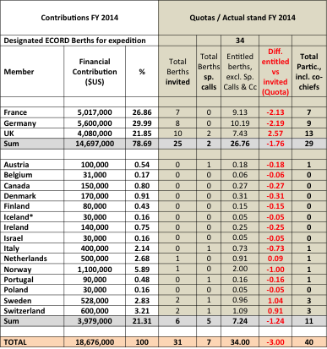

The projected quotas for 2014 and 2015 are ok for the UK and Germany, but France has to work on it (Table 6). Overall, more ECORD participants sailed than the eight berths per *JR* expedition that are mentioned in the contract. The minimum number of designated ECORD berths based on the MoU is 81. The total number of participants in expeditions in 2014 and 2015 is 94 (Table 6).

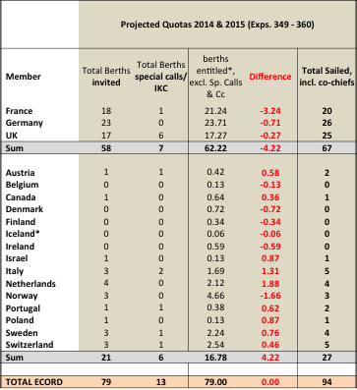Table 6: Projected quotas 2014 and 2015

The staffing for the upcoming *JR* expeditions after July 2015 has been completed (#356: Indonesian Throughflow) or is almost completed (#359: Maldives Monsoon and Sea Level). ECORD will have ten people on the *JR* Expedition 356. Five of them are from Germany. On Expedition 359 there will be also ten ECORD scientists and two of them are from special calls.

*JR* Expedition 360 (SW Indian Ridge Lower Crust and Moho) is completely staffed and there will be one Polish scientist sailing. *JR* Expedition 361 (Southern African Climates) is in the process of finishing the staffing. For this expedition there was also a special call for a nannofossil specialist.

A total of 82 applications were received for the next MSP expedition (#357: Atlantis Massif Serpentinization and Life). 43 of them are from ECORD scientists. The staffing is in process and the first invitations were sent in March. From ECORD there were more applications from senior scientists for the Atlantis Massif expedition, but together with the US, Japanese, Korean and Chinese partners the academic career distribution is balanced. There were no applications from India and Brazil. The Atlantis Massif expedition is staffed with 4 scientists from France, 1 from UK, 2 from Germany and 5 from small countries. The IKC berths for the UK are not counted. The Webinar associated to this expedition was very successful with 65 participants.

There are two open calls: 1) a special call for a nannofossil micropaleontologist for IODP Expedition 361; and 2) a call for applications for IODP Expedition 362 (Sumatra Seismogenic Zone). Until the middle of 2016 all expeditions should be staffed by the middle of this year.

For a simplification of the application process, the ESSAC webpage and the application form were revised. There is no longer an online application. Now all applications are done by email.

ECORD members in IODP panels:

G. Früh-Green continued to present the four new members for the SEP from January 2015 to December 2017: Marguerite Godard (France), Steven Bohaty (UK), Werner Piller (Austria) and Marc-André Gutscher (France).

The new members for the EFB starting in January 2016 are Gilles Lericolais (ECORD), Fumio Inagaki (Japan) and Stephen Gallagher (Australia). These new members were already approved by the ECORD Council. Jan-Hinrich Behrmann (GEOMAR, Kiel, Germany) has been elected as the new ESSAC Chair starting in 2016.

EGU:

There will be a special IODP-ICDP session at the EGU in April 2015. This session ‘Achievements and perspectives in scientific ocean and continental drilling’ will be convened by G. Früh-Green.

Education and outreach activities:

**DLPs** - A new Distinguished Lecturer Programme was set up. This time there are five speakers who cover the themes of the Science Plan. Two cover the topic ‘Climate and Ocean Change’ and the other three cover the three topics ‘Biosphere Frontiers’, ‘Earth in Motion’ and ‘Earth Connections’.

**ECORD Schools** - Every year ECORD Summer Schools are funded with a budget of 20,000 €. Traditionally there are the Urbino Summer School in Paleoclimatology and the ECORD Bremen Summer School with a different theme every year. The Bremen 2015 Summer School will concern ‘Ocean crust processes: magma, faults, fluxes and life’. Scholarships are offered to students to be able to attend these summer schools. Usually there are 50-60 applications for the summer schools and the ESSAC delegates decide together with the summer school organizer on who will get these fellowships. Four to five scholarships are given for the attendance of the summer school in Bremen and 10-12 for the Urbino Summer School. The annual budget for the ECORD Scholarships is 15,000 €. The application deadline for the call to host an ECORD Summer School in 2016 is the 5th of May.

In addition to the two traditional summer schools, ECORD co-funded the International School on Foraminifera in June 2015 in Urbino. The ECORD Council approved a funding of 5,000 € to support 4-5 ECORD students to attend this course.

A new ECORD Training Course was held in Bremen in March 2015 : ‘The Virtual Drillship Experience’. In total 53 applicants and 30 participants from ECORD and non-ECORD countries were accepted. This very successful course was funded by ECORD with 7,500 € and it will be probably continued in the future.

**ECORD Grants** - ECORD Research Grants are given every year with a total budget of 15,000 €. Up to 2,000 € are given to a single PhD student, an early-career or postdoctoral scientist for IODP based research.

**‘Teachers at Sea’** - The ‘Teachers at Sea’ is a very successful outreach programme. In 2015 Diane Hanano is sailing on Expedition 354: Bengal Fan.

**ECORD publication database** - Teresa Bingham was hired temporary and part-time through ETH (ECORD funds) to help setting up a publication database for all ECORD related literature. She will provide information on her progress at the next ESSAC meeting in May.

ESSAC news will be distributed monthly through the ESSAC distribution list.

* **Action (G. Camoin):** to contact M. Webb to negotiate the number of berths for the IKC for the Atlantis Massif expedition
* **Action (G. Camoin):** to send the FY15 ECORD budget table to G. Früh-Green

DISCUSSION on the ESSAC news:

Teachers at sea are a task for the operators. Responsibilities for this position at sea have to be set up and the expectations for teachers going out to sea have to be clearly defined. There are for all the same expectations and the teachers have to know what they can and cannot do. Within the next few months these guidelines will be established for the *JR* (T. Janecek). The funding for US teachers at sea is different from the ECORD funding. ECORD implemented some help with the funding of travels for ECORD teachers (G. Früh-Green). It helps to have clear guidelines.

It would be important to get in contact with nannofossil biostratigraphers from the summer schools because they are needed on expeditions (D. Kroon). This issue could be brought up at the next ESSAC meeting (G. Früh-Green). The problem at the universities is that this kind of stratigraphy is disappearing because it is not applied (D. Kroon). In the US there are two universities primarily training nannofossil students and professors associated with these programs are close to retirement (T. Janecek). ESSAC can contact people if this expertise is missing for an expedition (G. Früh-Green). However, this does not solve the problem of the following generations.

A. Moscariello asked for the upcoming MagellanPlus workshops. In 2014 six MagellanPlus workshops were held and in 2015 there will be five workshops (G. Camoin). The workshop ‘South Atlantic Drilling’ was already done in February. The upcoming workshops are the IMAGE/MEDGATE Project and the ‘Indian Ocean Crust and Mantle Drilling’ workshop in May, ‘Mantle, Water and Life’ in June and ‘Submarine Paleoseismology’ in July. This year an external review of the MagellanPlus workshop programme has to be organised (G. Camoin). 20,000 € are allocated every year for ADP workshops (G. Camoin). About one year ago ECORD decided to extend the MagellanPlus workshop funding to travels for ECORD scientists attending workshops outside of ECORD countries.

# 5 – ECORD-ILP News (A. Moscariello)

(11:57)

A. Moscariello summarized the ECORD-ILP activities. There are three focus activities of the ILP in 2015: 1) to involve and educate a larger number of possible Industry partners in ECORD/IODP activities; 2) to organise one ILP annual event; and 3) to ensure an active participation of Industry representatives at the MagellanPlus workshops. Most of the ILP members are from the oil and gas industry (BP, Eni, Total, ExxonMobil, Shell, Statoil, BG Group). But there are also two service companies (Schlumberger and ION).

Focus activity 1: The new members are the BG Group and Schlumberger as Industry partners and UK-IODP KEF (Sally Morgan) as an observer.

Focus activity 2: The last ILP meeting was in September 2014 in Bremen and focused on the topics in which industry is very interested, like the Niger Transform Margin, the Arctic and the Mediterranean. The expression of interest for this workshop came from Shell, BG Group, ION, Statoil and Schlumberger.

Focus activity 3: The MagellanPlus workshop ‘Drilling the Cretaceous-Palaeogene tropical South Atlantic’ was held in February 2015 in Newcastle. Five representatives from Industry (one from the BG Group and four from Shell) attended this workshop. ION and CGG Veritas provided seismic lines.

A. Moscariello continued to present the IODP Pre-proposal 864: ‘The Origin, Evolution and Palaeoenvironment of the Equatorial Atlantic Gateway’. There is lack of data for the Southern Atlantic and this project is an example for the collaboration of the science community with Industry.

A. Moscariello summarized other ILP activities. There are discussions on how combining the ECORD/ILP visibility with ECORD outreach. The next AAPG Annual Convention and Exhibition is in Denver from May 31st to June 3rd 2015. There are also Offshore Technical Conferences. The MagellanPlus workshops provide also a good possibility to increase the JAMSTEC visibility.

DISCUSSION on ILP activities:

There are mostly representatives from oil industry at the ILP, but it is important to try to find some contacts in other fields of Industry like water resources (G. Camoin). So far there is no progress on this issue (A. Moscariello). With the development of the ADP concept there will be a couple of proposals, like the one offshore Nice, dealing with water resources (G. Camoin). These Industry representatives have to be involved at an early stage and if A. Moscariello is aware of such proposals then he can look for contacts. For ICDP there is a programme on drilling the Rhône Valley and they have a lot of support from local water supply companies (A. Moscariello). In this context, K. Gohl mentioned the offshore New England hydrogeology proposal that is in the holding bin of the EFB. The scientific community should be educated to contact ECORD ILP in order to make a liaison with Industry (A. Moscariello). Developing collaboration with Industry should primarily come from the applicants (K. Gohl).

A pre-proposal will be developed from the MagellanPlus workshop ‘The Origin, Evolution and Palaeoenvironment of the Equatorial Atlantic Gateway’ (K. Gohl/A. Moscariello). This will be a *JR* expedition (A. Moscariello). There has been already a pre-proposal by Wagner et al. that was highly rated by SEP but the SEP wanted to know more about CPP possibilities and they wanted to have a more focused programme (D. Kroon). There is one team from Newcastle that wants to go to the North African coast and another team going to the Brasilian coast. The proponents are working on two different proposals with making reference to each other (A. Moscariello). The Brasilian side is much more advanced in terms of collaborating with industry, data availability and the maturation of the project (A. Moscariello). The Brasilians are planning to submit a proposal in 2016. The next deadlines for proposal submission are April 1st and October 1st.

(12:18)

lunch break

(13:59)

# 5 – ECORD post FY18 renewal and ESO & EMA post FY16 renewals (G. Camoin)

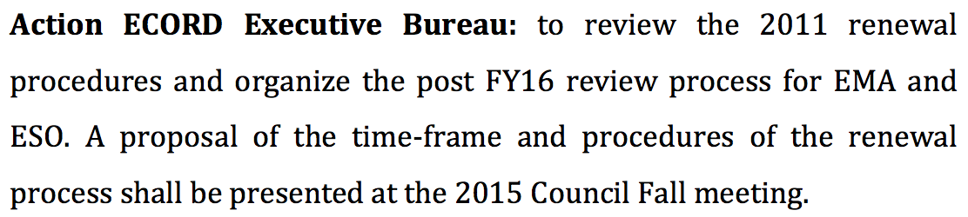G. Camoin reported on the renewal processes for ECORD, EMA and ESO. At the last ECORD Council-ESSAC meeting in Zurich in 2014 there was an action for the ECORD Executive Bureau:

EMA and ESO renewals:

The question is if the EMA & ESO renewals have to be combined with the post FY18 ECORD renewal. EMA and ESO will stay with France and the UK at least until the end of FY16. In this case the procedures for EMA & ESO renewals have to be already organized next year starting at the beginning of FY17. At the ECORD Council-ESSAC meeting in Zurich there was a consensus on combining the ECORD renewal processes, i.e. to have a review of the ECORD activities in FY17 and to review at the same time the EMA and ESO activities. Otherwise there should be one review process next year and a second review process on the ECORD activities starting one year later. Furthermore, a separate application process was discussed with having first a renewal of the operator and then a renewal of the management.

G. Camoin suggested organizing an Executive Working Group to discuss this issue by email and to present the procedure and a timeline for these processes at the next ECORD Council meeting in October 2015 in Naples. Should a new operator be nominated in 2017 or should the process be postponed to early 2018 to more or less the same time for the review of the ECORD activities. The major objectives of this working group are 1) to decide on combining or not the ESO and EMA renewals with the ECORD renewal process; and 2) to decide on how to deal with the external review.

ECORD renewal:

Concerning the ECORD renewal, most of the countries are committed until FY18, i.e. in 2017 the funding agencies have to decide on the commitment beyond FY18. In 2017 an external review has to be organized similar to the review in 2011 to get a final report on the review of the ECORD activities. This report has to be submitted to the funding agencies. Concerning the evaluation of the ECORD activities, the composition of an external committee, the selection of members and the evaluation procedures have to be discussed. G. Camoin presented 1) the Terms of Reference for the ECORD evaluation committee in 2011 (Fig. 2); 2) a timeline for this committee (Fig. 3) to review all activities and to produce a final report that is needed to convince the funding agencies; and 3) the composition of this external review committee, i.e. people who are not directly involved in ECORD.

Figure 2: Terms of Reference for the ECORD evaluation committee in 2011

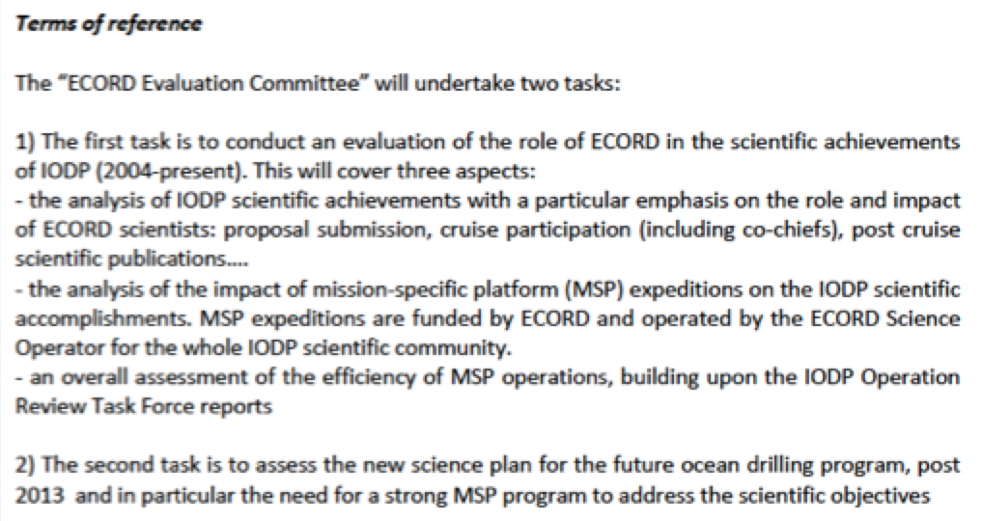

Figure 3: Timeline for the ECORD evaluation committee in 2011

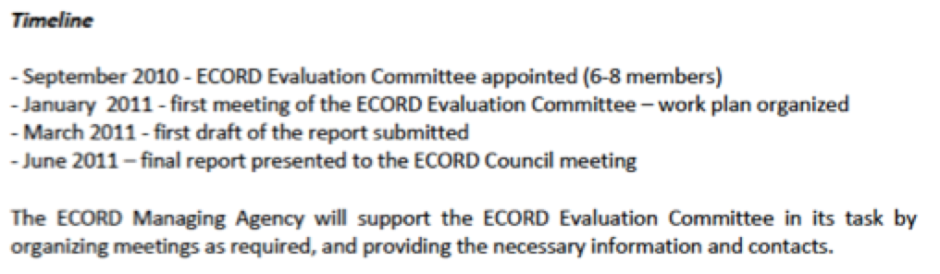

DISCUSSION on the ECORD, EMA and ESO renewal processes:

T. Janecek asked if there is any specific information needed from NSF with respect to the ECORD renewal processes. The kind of information that T. Janecek already provided today and the decisions that are expected before summer will help to sharpen the plans for the evaluation of ECORD activities (G. Camoin).

In the last years of the previous programme phase there was a consensus by the ECORD Council regarding the extension of a mandate for the first three years of the new phase to ensure a smooth transition of ESO and EMA to the new programme (J. Surma/G. Camoin). That means that either ESO or EMA or both have to be renewed early FY17. During the Council meeting in October 2014 it was said that an external review of ESO and EMA activities is needed in 2016 (G. Camoin). A review of ESO and EMA includes performance and finances (K. Gohl/G. Camoin). The ECORD activities have to be reviewed in 2017 and that is why it was mentioned at the Council meeting in Zurich to combine the renewals in 2017 (G. Camoin). The timing for ECORD’s renewal is because most of the funding agencies are committed until the end of FY18. The working group has to decide on what to propose. Either renewing ESO and EMA or at least one of them in early FY17 or having a general review of the ECORD activities and to see how to deal with a new application process for hosting the operators and the management (G. Camoin). It would make sense to combine the renewals in one review (G. Lüniger). If there are no legal issues, it would be good to extend the term of ESO and EMA for a couple of years without any new contract (G. Lüniger). The Council can make a motion on extending the terms for the BGS and the CNRS, and to keep the operations and the management until the end of at least FY17 (G. Camoin). That means that in FY17 ECORD has to organize an external review and at same time to open a call for applications for the operations and the management (G. Camoin). It is better to open a call for applications for ESO and EMA to have a transparent process and ECORD has to see the various applications and their benefits (G. Camoin). It is important to open a new competition and the Council will know the costs and can see potential cost savings when the applications were received. For example, the overhead should be negociated (K. Gohl). One external review is recommended to save time and to use this external report as a kind of legacy for the operations and the management and for issueing a new call for applications (G. Camoin). In order to find out if it is worth to do another call for applications, it would be helpful to find out if there is any interest in hosting ESO and EMA from other countries (K. Gohl). This could be done with an informal call for interest to assess the potential. If there is no other organisation interested and taking the financial burden for the changeover into account, then the contract for ESO and EMA should be extended (K. Gohl).

For the external committee it is good that ECORD publishes every year an annual report that also shows the budget tables for all ECORD entities. This was not the case for the ECORD evaluation committee in 2011, i.e. an external review is much easier now (G. Camoin).

There is the question if one working group can have the appropriate expertise to evaluate the finances and operations of a drilling contract or of a programme coordinator (T. Janecek). The external review committee in 2011 was composed of seven people and it is possible to have people covering the various fields, like education and outreach, funding and management, operations and science, who can judge the ECORD activities (G. Camoin). The final decision on the procedures of the renewals will be taken by the ECORD Council.

* **Action ECORD Executive working group (G. Lüniger, M. Diament, K. Gohl, G. Camoin, R. Gatliff, M. Webb):** to work by email on the timing and procedures of ECORD’s renewal and to propose to the ECORD Council if the EMA and ESO renewals should be combined with the ECORD renewal or not
* **Action (G. Camoin):** to send all documents concerning the 1st call for applications for the operators and the management when ECORD was created, and all documents concerning the external review from 2011 to the Executive working group members as an example
* **Action (G. Camoin):** to contact M. Webb if he wants to be member of the Executive working group on the renewal of ECORD, ESO and EMA

M. Webb agreed by email to be part of this Executive Working Group.

# 6 – Update on active MSP proposals (K. Gohl)

(14:27)

K. Gohl gave an overview of the seven MSP proposals at the EFB (Table 5). Four of those (581, 637, 708 and 716) are in the EFB holding bin and three are scheduled (548, 758 and 813). Expedition 357 is scheduled for the end of this year and Expedition 364 is scheduled for early 2016 under the provision that ECORD sets a limit of $8.5M USD.

Table 5: MSP proposals at the EFB

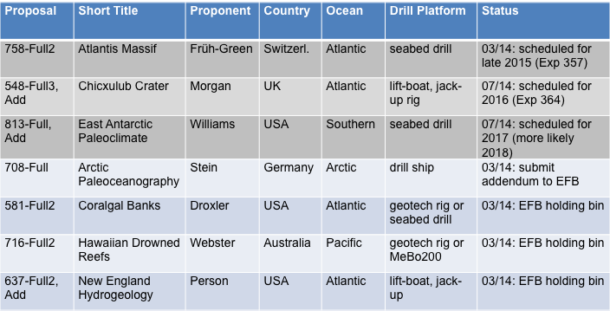

Last year the proponents of MSP proposal 813 submitted an addendum that was accepted last July by the EFB during a virtual conference and the EFB agreed on scheduling this proposal. The initial cost estimate was $3.5M USD assuming the US icebreaker RV *N. B. Palmer* as an IKC. However, the icebreaker will not be an IKC and the expedition costs will be of $10.5M USD (K. Gohl). The RV *N. B. Palmer* from NSF is the only option and the $10.5M USD also include ESO expedition costs (D. McInroy). The transit of the RV *N. B. Palmer* could be filled with other expeditions and thus the costs for ECORD could be reduced if a commitment is made early enough (T. Janecek).

MSP proposal 716 is a geotech rig or seabed drilling operation. Seabed drilling is only possible with the MeBo200 because of the penetration depths of 150 m. The MeBo200 is not yet fully in operation. It has been tested last year in the North Sea but it still needs a full test. In the North Sea there was a visibility problem because of the weather conditions. The first MeBo200 expedition will be an internal operation by MARUM and it will be offshore New Zealand in early 2016 (K. Gohl). ECORD cannot expect to use the MeBo before 2020 (G. Camoin).

MSP proposal 637 is in the holding bin because this would be an expensive operation with costs being in the range of $16 to $40M USD depending on the options being used. This expedition is so expensive because the proponents plan to drill ten holes: five coring holes and five logging holes with logging while drilling (D. McInroy). The proponents made a compromise and plan not to do logging while drilling anymore but to do wireline logging (D. McInroy). In this case the platform could be smaller and the costs would be reduced.

At the moment there is only one Arctic proposal at the EFB: MSP proposal 708. For this proposal K. Gohl has an institutional conflict of interest. Mid-March the proponents submitted an addendum to the EFB together with new site survey data that they collected last summer. The proponents have the same objectives in the addendum but they provide better arguments why the selected sites are the optimal study sites. It is an expensive operation because a large water depth is combined with a large penetration depth. All icebreaker support could be IKCs (K. Gohl). The Russians could offer an icebreaker. Furthermore, the Swedish RV *Oden* and the German RV *Polarstern* will be in this area and could come as IKCs.

DISCUSSION on proposal 708 and collaboration with Industry:

Industry is interested in the Arctic but for many companies the Arctic is off-limit due to environmental issues, i.e. they cannot officially go there. But they might be interested to be onboard of scientific expeditions. ECORD has to make clear how to collaborate with Industry (A. Moscariello). For the Arctic, ECORD has to be clear regarding environmental and political issues and Industry should not be involved (M. Diament). ECORD should strictly stay on the scientific side (M. Diament). At the next ECORD Council meeting the question about the collaboration with Industry in sensitive areas like the Arctic and the Antarctic has to be asked (G. Camoin). A clear statement has to be made and the Council has to decide at which level ECORD collaborates with Industry (G. Camoin). ECORD has to be very careful with any collaboration with Industry in the Arctic and there should not be an official IODP-Industry agreement for a common project in the Arctic (K. Gohl). However, K. Gohl suggested that sharing a platform with Industry to save mobilisation costs could be a possible scenario. For example, there could be a contract time for IODP and when this time is over then Industry could take over. This would not be an official collaboration with Industry but it would be cost sharing with Industry (K. Gohl).

Proposal 708 is pushing the technology a lot because of the location and the depth of the study sites. Drilling a deep hole needs a bigger drill rig and a bigger platform. Furthermore, ice is an issue and there is a big risk that the Oligocene sequence is not reached. Overall, this is a high-risk and high-cost proposal. The risks should be mitigated (R. Gatliff). Concerning the mitigation of the risks, the study area was the only ice-free region in the Artic during the season when the proponents went there (K. Gohl). This region is probably safer than ACEX-1 and any other region in the Central Arctic (K. Gohl). In addition, there would not be so many options regarding water and penetration depths.

K. Gohl gave an overview of the 14 active Pre- and Full MSP proposals at the SEP (Table 6). There is a good mixture of proposals regarding the study area, the costs, the scientific objectives and the used platform.

Table 6: MSP proposals at the SEP. The order is according to the relative maturity. The asterisk indicates that ECORD co-funding may be considered.

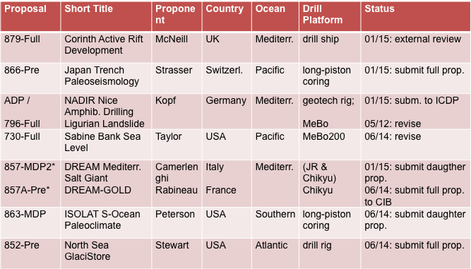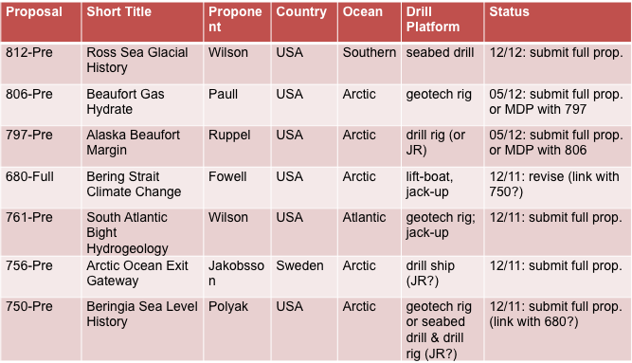

The first seven proposals in the table have been active this year or last year. Proposal 879 is an expensive operation in the Gulf of Corinth and it has been a *JR* proposal. However, the Gulf of Corinth is not accessible by the *JR* and that is why it turned into a MSP proposal. Pre-proposal 866 is a relatively cheap long-piston coring expedition with a possible regular research vessel as an IKC from Japan. Proposal 796 is the first proposal in the new ADP category. The DREAM proposal is listed in this table because of a contribution from ECORD to this *Chikyu* operation (K. Gohl). This project will be listed at the CIB with the *Chikyu* proposals (G. Camoin).

In the second part of the table there are proposals that were for the last time active in 2011 or 2012, i.e. the proponents did not reply since then. Within these proposals there are four Arctic proposals that are all on the Alaskan side of the Arctic. But nothing happened with these proposals. The proponents do not have to respond now because the *JR* will probably not go to this area until 2020-2022.

K. Gohl continued to present the budget that is available for MSP expeditions (Table 7). Shown in the table is the available budget at the end of each FY, the scheduled drilling operation for the particular FY and the average expedition cost estimates from ESO.

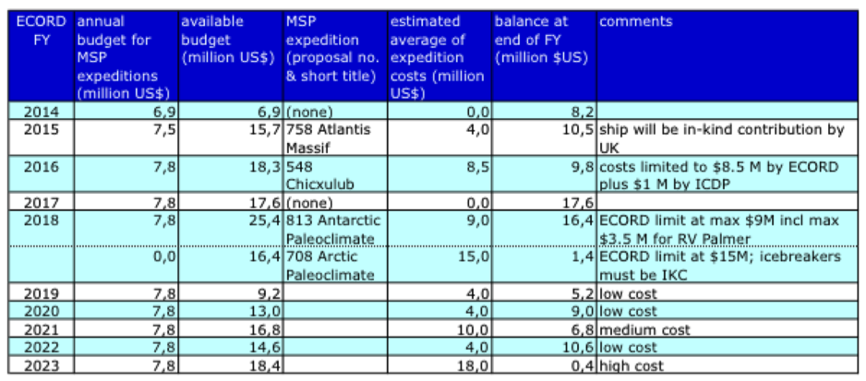Table 7: EFB budget calculation for MSP expeditions. The costs are pure expedition funds without ESO fixed costs.

The ECORD contribution to the Chicxulub and the Arctic Paleoclimate expeditions are $8.5M USD and $15M USD, respectively. The costs for the Antarctic Paleoclimate expedition increased, including now the full costs for the US RV *N. B. Palmer*. The RV *N. B. Palmer* is available in 2018 and not in 2017 (K. Gohl). The ship costs for the RV *N. B. Palmer* are about $5.5M USD for the Antarctic Expedition (T. Janecek). Both expeditions, the Arctic and the Antarctic, could be implemented in 2018 (K. Gohl). Negociations with NSF have to be continued on reducing the cost for the RV *N. B. Palmer* (K. Gohl). The daily costs for the RV *N. B. Palmer* are on the order of $55,000 USD (T. Janecek). There is also the option to fill the FY17 or early FY18 with a low-cost expedition, like Coralgal Banks, from the EFB holding bin (K. Gohl).

There is a problem to match facilities like the seabed drilling and long-piston-coring with available research vessels because there can be different operators from even different countries who work on totally different schedules (K. Gohl). This is a challenge for ESO and the ECORD Council but also for the proponents to take care of this already very early in the process. Something should be written in the call for MSP proposals that the proponents should think about how to convince their funding agencies and they should talk to the operators of their research fleet so that at the end there is a viable and realistic plan with ESO (K. Gohl). For example, proposal 813 could have been a low-cost operation when at the beginning the proponents would have written a NSF proposal to get the ship time for the RV *N. B. Palmer* for free and ECORD could have supplied the drilling platform. At least for regular research vessels, the proponents need to be more proactive if they want to use a mix of platforms.

At the last ECORD Council meeting three plans were discussed: 1) to follow the present schedule and to ask NSF to reduce the costs for the RV *N. B. Palmer*; 2) to replace the expedition for proposal 813 with a low-cost expedition, e.g. Coralgal Banks; and 3) to shift the expedition for proposal 708 by one year to 2019. This range of options has to be finalized at the upcoming EFB meeting.

Concerning the reservation for the MeBo, K. Gohl had a meeting the week before with M. Schulz, G. Wefer and T. Freudenthal at the MARUM in Bremen and tried to fix reservations for the MeBo70 and MeBo200. Like discussed at the last ECORD Council meeting, ECORD should try to make reservations for the MeBo already years ahead without actually knowing which expeditions will be scheduled, so that this equipment is available for ECORD operations. The equipment can be booked for ECORD use for a time window or a certain year even if then the MeBo is not used. There are many interested parties in the use of the MeBo. Until the end of the current IODP programme phase there will be many more low-cost operations. In the total 10 years of the programme only two high-cost operations (~$20M USD), maybe 2-3 medium-cost expeditions (~$10-20M USD) and the rest are low-cost operations (~$5-6M USD). The 5-years planning has to be extended for provisional planning, i.e. expeditions do not have to be fixed (Table 7). This is important for the long-term planning of the reservations of equipment.

For any proposal that will be scheduled during the upcoming EFB meeting, a call for applications for IKCs has to be issued by EMA and ESO (G. Camoin). This could maybe also concern the Antarctic expedition. Experience with research vessels operators in different countries shows that they operate with a different philosophy and funding system (K. Gohl). These agencies would probably not make a commitment for IKCs if the expedition is not yet scheduled. Five years from now would be too long for them. However, if the time is too short then the vessels could be already booked for national projects. A call would be good to show them the request for a research vessel (K. Gohl). Such a call is open to any country (G. Camoin). T. Janecek noted that the US and UK have a barter system in place for ship time and that it might be useful for ship schedulers from NSF, UK, and ECORD to discuss barter possibilities.

(15:27)

coffee break

(15:49)

# 7 – Procedures for ICDP-IODP joint review of amphibious proposals (K. Becker)

K. Becker presented the new procedures regarding the amphibious proposals. At the first IODP Forum meeting in 2014 a motion has been made to work with ICDP and to design a process to jointly evaluate proposals. The IODP Forum recommended setting up a working group. ICDP agreed and this working group was set up and chaired by Kenneth Miller (IODP SEP). The further members of this group are Pierre Francus (ICDP EC), Flavio Anselmetti (ICDP SAG), Jochen Erbacher (IODP Forum) and Sean Gulick (IODP SEP).



The definition of ADP’s is as follows (revised version from April 3rd, 2015):

There are two principles for the coordinated evaluation of ADP’s:

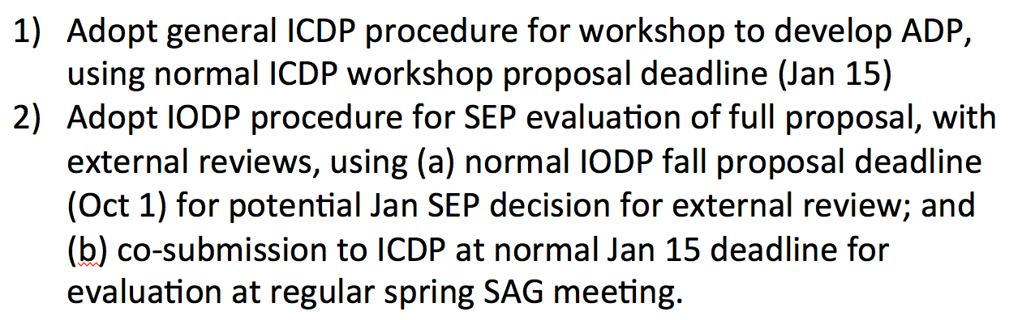

One difference between ICDP and IODP is that ICDP has one annual cycle of proposal review and IODP has two proposal deadlines separated by six months.

The document ‘IODP ICDP Guidelines for joint review of “Amphibious Drilling Proposals” (ADP’s)’ will be reviewed this spring at the EFB, CIB and JR-FB, then at the ICDP Executive Committee in June and the IODP Forum in July. If there is an agreement, then it will be adopted by both programmes.

ADP’s generally require workshops to bring together members of the IODP and ICDP communities and to justify the scientific need for both onshore and offshore sites (K. Becker). In the normal process for ICDP a workshop proposal is a requirement but exceptions are allowed in case the proponents are well prepared (K. Gohl/K. Becker). Workshop proposals will be reviewed by the ICDP SAG/EC and the IODP SEP with, if necessary, the advice of any external potential funders of workshops (K. Becker). Workshop funds will be provided by ICDP and the IODP national committees (ECORD, USAC, J-DESC).

K. Becker continued to present two flow charts for the development of an ADP workshop and an ADP full proposal (Figs. 4 and 5).

Figure 4: IODP-ICDP Amphibious Drilling Proposal (ADP) Development: Workshop

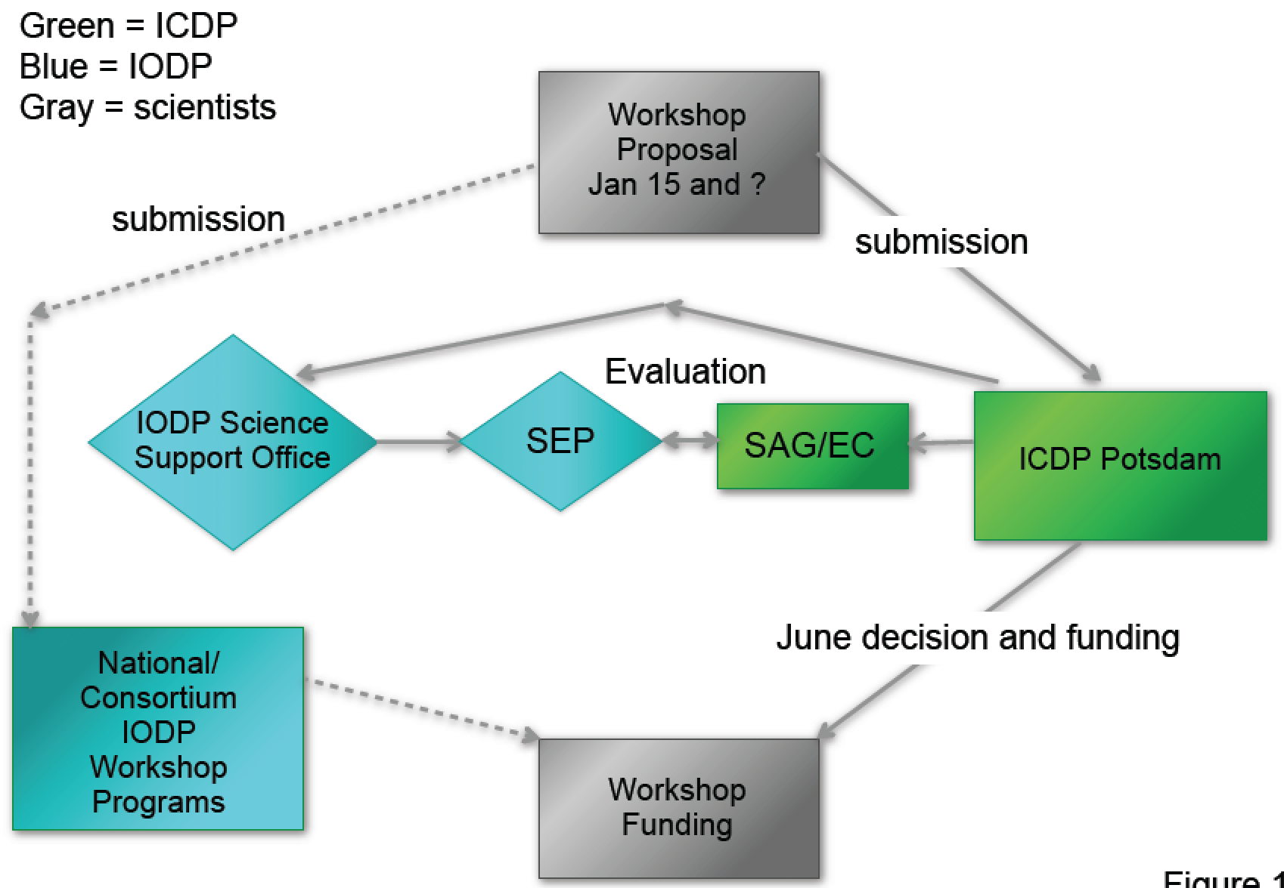

On IODP side the workshop proposal will be sent to the Science Support Office that forwards the proposal to SEP for evaluation. At the same time the workshop proposal goes to the ICDP SAG/EC for evaluation. G. Camoin mentioned that MagellanPlus is not in this diagram. It is up to the proponents to think about this system on the IODP side (K. Becker). MagellanPlus is funded by ECORD and ICDP (G. Camoin). ECORD and ICDP decided to put 10,000 € each to fund ADP workshops. Proponents are looking for multiple sources of funding and the expectation is that the workshop becomes a proposal (T. Janecek). It is mentioned in the ADP guidelines that the procedures, e.g. for MagellanPlus and USAC, have to be followed (K. Becker). This is a discussion item for the IODP Forum (G. Camoin).

An important issue is to have the recognition that the proposal is an ADP proposal (G. Camoin). The question is if a proposal has to follow the process that is shown in Figure 4 or if it can go directly through MagellanPlus and be submitted directly to the Science Support Office to be recognized as an ADP proposal (G. Camoin). The second option would require approval by the ICDP EC (K. Becker). There should be a different flow chart where proponents submit a proposal without going through a workshop (K. Gohl). SEP is not evaluating workshop proposals.

Figure 5: IODP-ICDP Amphibious Drilling Proposal (ADP) Development: Full Proposal

Full ADP proposals should be submitted for the normal IODP October 1st deadline and co-submitted for the ICDP January 15th deadline. If a full ADP proposal is positively reviewed at the January IODP SEP, the IODP Science Support Office will obtain fast-track external review in time for the spring ICDP SAG meeting. Following this external review, the Full ADP will be evaluated by the scientific panels of both programmes (spring SAG and June SEP). Those recommendations will be integrated into a single review document. It is up to the chairs of these two panels to organize a joint evaluation. This single evaluation document goes to both the ICDP EC and the respective IODP Facility Board. The key aspect is to get an integrated review and to avoid that the proponents get contrasting reviews (K. Becker).

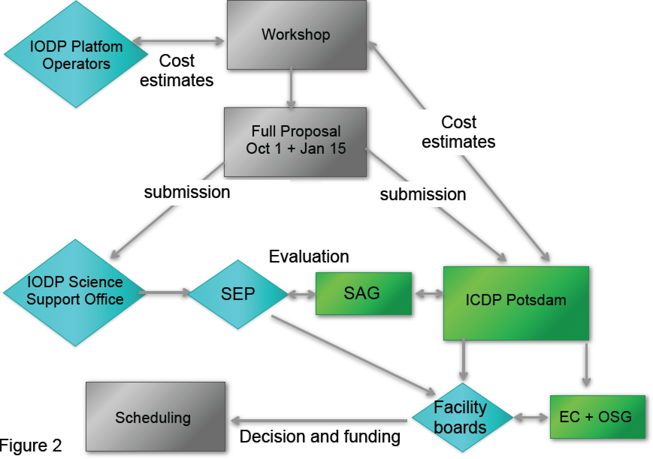

At the January SEP meeting the SEP might recommend to send the full proposal out for external review. If they send it out for external review, at the following June SEP meeting SEP can recommend a revision (K. Becker). The ICDP SAG at its spring meeting can also recommend revisions. Those two review statements would be integrated into a single review. This might require a resubmission of the proposal that would go through the same process (K. Becker).

There is the question if the cores are all under IODP regulations because ICDP has different policies on samples and data (K. Gohl). There has to be a policy after approval of the ADP guidelines (K. Gohl/K. Becker). A new policy is not necessarily needed (T. Janecek) as ICDP and IODP have their respective cores and policies and the reporting can be done separately (T. Janecek). ICDP is flexible, i.e. the cores are often archived in the host country where the drilling took place.

# 8 – Overarching public relations + educational activities (P. Maruéjol/G. Camoin/K. Becker)

(16:16)

P. Maruéjol presented the overarching IODP outreach and education activities. During the first IODP programme between 2003 and 2013 the entities EMA, ESO and ESSAC collaborated on outreach and education within ECORD and there was collaboration with the national offices. Outside ECORD there was collaboration through the IODP-MI Office with the US, Japan and other partners.

Since October 2013 there is no IODP-MI Office anymore. However, ECORD is inviting US and Japanese colleagues to the ECORD outreach and education meetings. ECORD also promotes IODP and its partners at scientific events. For example, at the AGU ECORD had a joint booth with ICDP. Furthermore, there was a joint IODP/ECORD/ICDP Townhall Meeting at the AGU 2014. ECORD distributes information about its partners at the booths of scientific conferences. In addition, ECORD participates at the ‘Teachers at Sea’ programme and ECORD is exchanging information with the Science Support Office on the webpages.

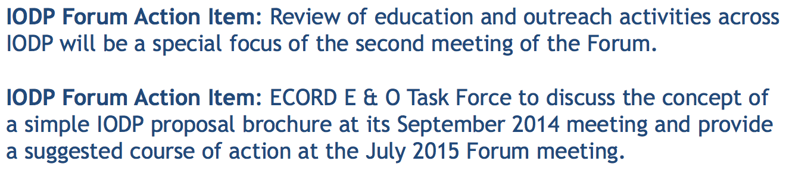The visibility of all IODP members has to be increased and the exchange on outreach and education activities has to be continued. Outreach and education was discussed at the first IODP Forum in 2014 and there are two action items for the next IODP Forum meeting in July 2015:

ECORD proposes a common brochure for IODP and its partners which includes maps, tools and contact information but that also provides information on how to get involved in IODP.

DISCUSSION on outreach and education activities:

The second IODP Forum in July 2015 will have a special focus on education and outreach across IODP (K. Becker). That is why it is important that all entities (ECORD, the US and Japan, but also the partners) involved in outreach and education have representatives at this meeting. It is important for the visibility of the programme to coordinate these actions (G. Camoin). For example, having different booths at the AGU is probably not the best way. One good point would be the production of a joint IODP brochure that each entity can distribute at national meetings (G. Camoin). This coordination is an IODP Forum task (G. Camoin).

There are many advantages to share the ECORD outreach and education meetings with the US, the Japanese and partners like ICDP. This meeting is a good platform to discuss the joint booths, the joint Townhall Meetings, the joint brochure, the ADP’s and the *Scientific Drilling* journal (G. Camoin/P. Maruéjol). There was also an informal meeting at the last AGU to discuss outreach and education activities across IODP (G. Früh-Green). At the next IODP Forum there should be also exchanges with the other entities, like ANZIC, China and India (G. Camoin). K. Becker can ask each country to report at the upcoming IODP Forum meeting on outreach and education activities in their own countries.

There is some progress with a brochure at the ECORD level but not at the IODP level (P. Maruéjol). The brochure has to be kept simple showing IODP and its partners including maps and contacts. A common text could be on one side and information on the specific member could be on the other side (P. Maruéjol). This brochure shall address the scientific audience. It still has to be decided on the information provided in this brochure. Maybe it should be focused on how to get involved in IODP. Such a brochure was used in Canada, Ireland and Portugal (P. Mauéjol). J-DESC is also making this kind of brochure (N. Eguchi). The question is if a single IODP brochure or a brochure with IODP information on one side and ECORD, ANZIC, etc. information on the other side should be used (P. Maruéjol). The overarching outreach and education activities and ideas on how to interact across the programme have to be presented at the upcoming IODP Forum (G. Camoin).

# 9 – Next meetings – ECORD attendance (G. Camoin)

(16:39)

G. Camoin presented a list of the next meetings and conferences and started a discussion on the ECORD representation at these meetings.

*Chikyu* IODP Board, Yokohama, Japan in March 2015

G. Camoin, K. Gohl, N. Hallmann

EGU, Vienna, Austria in April 2015

*JR*-FB, Arlington, USA in May 2015

M. Diament, G. Camoin, K. Gohl, D. Kroon, N. Hallmann, maybe G. Lüniger

SEP #4, Brest, France in June/July 2015

S. Davies, K. Gohl, S. Morgan

IODP Forum #2, Canberra, Australia in July 2015

G. Camoin, R. Gatliff, K. Gohl, D. Kroon, N. Hallmann, G. Lüniger, J. Behrmann if G. Früh-Green cannot attend

ECORD OETF #8, Potsdam, Germany in October 2015

G. Camoin, G. Früh-Green, N. Hallmann, P. Maruéjol, A. Stevenson

One US colleague will attend this meeting at least by video conference. Furthermore, T. Omata from Japan and T. Wiersberg and M. Leng from ICDP will attend.

E. Neville from ANZIC and S. Tuo from IODP China has to be asked at the upcoming IODP Forum if they want to attend the ECORD OETF #8 meeting at least by video conference.

ECORD Council-ESSAC #3, Naples, Italy in October 2015

26th: field trip, 27th: ESSAC meeting, 28th and 29th: joint Council-ESSAC meeting

D. Weis will probably attend instead of G. Früh-Green and R. Stein will attend even if J. Behrmann attends.

IODP Day, Lisbon, Portugal in November 2015

AGU, San Francisco, USA in December 2015

The meeting was closed at 16:47.

# ROSTER

|  |  |  |
| --- | --- | --- |
| ***ENTITIES*** | ***NAMES*** | ***EMAILs*** |
| ECORD Council-F | Michel Diament | [diament@ipgp.fr](mailto:diament@ipgp.fr) |
| ECORD Council-GER | Guido Lüniger | [guido.lueniger@dfg.de](mailto:guido.lueniger@dfg.de) |
| ECORD Council-UK | Michael Webb* | [mweb@nerc.ac.uk](mailto:mweb@nerc.ac.uk) |
| ECORD Council-UK (Alt.) | Jessica Surma (Alt.) | [jetc@nerc.ac.uk](mailto:jetc@nerc.ac.uk) |
| ECORD Council-CH | Martina Kern-Lütschg | [mkern@snf.ch](mailto:mkern@snf.ch) |
| ECORD Council-DEN | Anders Kjaër | [akj@fi.dk](mailto:akj@fi.dk) |
| EMA | Gilbert Camoin | gcamoin@cerege.fr |
| EMA | Nadine Hallmann | hallmann@cerege.fr |
| EMA | Patricia Maruéjol | maruejol@crpg.cnrs-nancy.fr |
| ESO | Robert Gatliff | [rwga@bgs.ac.uk](mailto:rwga@bgs.ac.uk) |
| ESO | David McInroy | [dbm@bgs.ac.uk](mailto:dbm@bgs.ac.uk) |
| ESO | Alan Stevenson | [agst@bgs.ac.uk](mailto:agst@bgs.ac.uk) |
| ESSAC | Gretchen Früh-Green | frueh-green@erdw.ethz.ch |
| EFB | Karsten Gohl | Karsten.Gohl@awi.de |
| ECORD ILP | Andrea Moscariello | Andrea.Moscariello@unige.ch |
| SEP | Dick Kroon | dick.kroon@ed.ac.uk |
| IODP Forum | Keir Becker | kbecker@rsmas.miami.edu |
| NSF | Tom Janecek | [tjanecek@nsf.gov](mailto:tjanecek@nsf.gov) |
| CDEX – JAMSTEC | Nobuhisa Eguchi | neguchi@jamstec.go.jp |

*\*Apologized*

# LIST OF ACRONYMS

**AAPG:** American Association of Petroleum Geologists

**ACEX**: Arctic Coring Expedition

**ADP**: Amphibious Drilling Proposal

**AGU**: American Geophysical Union

**ANZIC**: Australian and New Zealand IODP Consortium

**BCR**: Bremen Core Repository

**BGS**: British Geological Survey

**BOP**: Blow Out Preventer

**CDEX**: Center for Deep Earth Exploration

**CIB**: *Chikyu* IODP Board

**CNRS**: Centre National de la Recherche Scientifique

**CPP**: Complementary Project Proposal

**DREAM**: Deep-sea Record of Mediterranean Messinian Events

**EFB**: ECORD Facility Board

**E-ILP**: ECORD Industry Liaison Panel

**ECORD**: European Consortium for Ocean

**EGU**: European Geosciences Union

**EMA**: ECORD Managing Agency

**ESO**: ECORD Science Operator

**ESSAC**: ECORD Science Support and Advisory Committee

**FY**: Fiscal Year

**GEOMAR**: Helmholtz Centre for Ocean Research Kiel

**ICDP**: International Continental Scientific Drilling Program

**ICDP EC**: ICDP Executive Committee

**IKC**: In-kind contribution

**IODP**: Integrated Ocean Drilling Program (2003-2013) & International Ocean Discovery Program (2013-2023)

**IODP-MI**: IODP Management International, Inc.

**JAMSTEC**: Japan Agency for Marine Earth Science and Technology

**J-DESC**: Japan Drilling Earth Science Consortium

**JFY**: Japanese Fiscal Year

**JOIDES**: Joint Oceanographic Institutions for Deep Earth Sampling

***JR***: *JOIDES Resolution*

***JR*-FB**: *JOIDES Resolution* Facility Board

**JRSO**: *JOIDES Resolution* Science Operator

**MARUM**: Center for Marine Environmental Sciences, University of Bremen

**MDP**: Multi-phase Drilling Project

**MeBo:** Meeresboden-Bohrgerät

**MoU**: Memorandum of Understanding

**MSP**: Mission-specific platform

**NanTroSEIZE**: Nankai Trough SEIsmogenic Zone Experiment

**NAS**: National Academy of Sciences

**NERC**: Natural Environment Research Council

**NSF**: National Science Foundation

**OCE**: Division of Ocean Sciences

**OETF**: Outreach and Education Task Force

**OOI**: Ocean Observatories Initiatives

**OSG**: Operational Support Group

**SAG**: Science Advisory Group

**SEP**: Science Evaluation Panel

**TBD**: To be determined

**USAC**: US Science Advisory Committee